**ENHANCING CONVERSATIONAL AI MODEL PERFORMANCE AND EXPLAINABILITY FOR SINHALA-ENGLISH BILINGUAL SPEAKERS**

2022-056

Project Status Document - I

Hameed M.S.

(Dissanayake D.M.I.M., Jayasinghe D.T., Sakalasooriya S.A.H.A.)

B.Sc. (Hons) Degree in Information Technology Specialising in Software Engineering

Department of Information Technology

Sri Lanka Institute of Information Technology

Sri Lanka

May 2022

**ENHANCING CONVERSATIONAL AI MODEL PERFORMANCE AND EXPLAINABILITY FOR SINHALA-ENGLISH BILINGUAL SPEAKERS**

2022-056

Project Status Document - I

B.Sc. (Hons) Degree in Information Technology Specialising in Software Engineering

Department of Information Technology

Sri Lanka Institute of Information Technology

Sri Lanka

May 2022

# Declaration, Copyright Statement

We declare that this is our own work, and this project status document does not incorporate without acknowledgement any material previously submitted for a degree or diploma in any other university or Institute of higher learning and to the best of our knowledge and belief it does not contain any material previously published or written by another person except where the acknowledgement is made in the text.

|  |  |  |
| --- | --- | --- |
| **Name** | **Student ID** | **A picture containing text  Description automatically generatedSignature** |
| Dissanayake D.M.I.M. | IT19069432 |  |
| Hameed M.S. | IT19064932 |  |
| Jayasinghe D.T. | IT19075754 |  |
| Sakalasooriya S.A.H.A. | IT19051208 |  |

# **Table of Contents**

Declaration, Copyright Statement i

Table of Contents ii

List of Figures iii

1. Microsoft Teams Screenshot 1

1.1 Calls with the team 1

1.2 Conversations with the team 13

1.3 MS Teams Planner Project Backlog 15

1.4 MS Teams Planner Charts 16

2. Git Logs 17

2.1 GitLab Branch 17

2.2 GitLab Contributions 17

2.3 Individual GitHub Repositories 19

3. Emails 20

3.1 Supervision requesting and confirmation emails 20

3.2 Topic discussion meeting scheduling 21

3.3 Research proposal draft review requesting emails 22

3.4 Progress discussion meeting scheduling 23

3.5 Topic assessments form review request 24

3.6 Research component changes review request 25

3.7 Topic changes review request after panel evaluation was done 26

3.8 Individual project proposal documents review request 27

3.9 Sharing the updated proposal presentation slides deck 27

3.10 Research progress discussion meeting before progress presentation – I 28

4. Gantt chart comparison 29

5. Work breakdown and task status 30

# List of Figures

[Figure 1.1.1. Topic assessment form preparation discussion meeting 1](https://mysliit-my.sharepoint.com/personal/it19064932_my_sliit_lk/Documents/status_doc_final.docx#_Toc103354649)

[Figure 1.1.2. Chatbot backend design planning meeting 1](https://mysliit-my.sharepoint.com/personal/it19064932_my_sliit_lk/Documents/status_doc_final.docx#_Toc103354650)

[Figure 1.1.3. Charter document preparation team discussion - I 2](https://mysliit-my.sharepoint.com/personal/it19064932_my_sliit_lk/Documents/status_doc_final.docx#_Toc103354651)

[Figure 1.1.4. Charter document preparation team discussion - II 2](https://mysliit-my.sharepoint.com/personal/it19064932_my_sliit_lk/Documents/status_doc_final.docx#_Toc103354652)

[Figure 1.1.5. Research proposal draft preparation discussion meeting 3](https://mysliit-my.sharepoint.com/personal/it19064932_my_sliit_lk/Documents/status_doc_final.docx#_Toc103354653)

[Figure 1.1.6. Files shared during the project proposal draft meeting - I 3](https://mysliit-my.sharepoint.com/personal/it19064932_my_sliit_lk/Documents/status_doc_final.docx#_Toc103354654)

[Figure 1.1.7. Gantt chart designed during the proposal draft discussion meeting - I 4](https://mysliit-my.sharepoint.com/personal/it19064932_my_sliit_lk/Documents/status_doc_final.docx#_Toc103354655)

[Figure 1.1.8. Gantt chart designed during the proposal draft discussion meeting - II 4](https://mysliit-my.sharepoint.com/personal/it19064932_my_sliit_lk/Documents/status_doc_final.docx#_Toc103354656)

[Figure 1.1.9. Survey planning and designing meeting 4](https://mysliit-my.sharepoint.com/personal/it19064932_my_sliit_lk/Documents/status_doc_final.docx#_Toc103354657)

[Figure 1.1.10. Files shared during the project proposal draft meeting - II 5](https://mysliit-my.sharepoint.com/personal/it19064932_my_sliit_lk/Documents/status_doc_final.docx#_Toc103354658)

Figure 1.1.11. Files shared during the project proposal draft meeting - III 5

[Figure 1.1.12. Ideas shared during proposal presentation planning discussion - I 6](https://mysliit-my.sharepoint.com/personal/it19064932_my_sliit_lk/Documents/status_doc_final.docx#_Toc103354660)

[Figure 1.1.13. Ideas shared during proposal presentation planning discussion - II 7](https://mysliit-my.sharepoint.com/personal/it19064932_my_sliit_lk/Documents/status_doc_final.docx#_Toc103354661)

[Figure 1.1.14. Proposal presentation demo meeting 8](https://mysliit-my.sharepoint.com/personal/it19064932_my_sliit_lk/Documents/status_doc_final.docx#_Toc103354662)

[Figure 1.1.15. Proposal presentation last-minute preparation meetings 9](https://mysliit-my.sharepoint.com/personal/it19064932_my_sliit_lk/Documents/status_doc_final.docx#_Toc103354663)

[Figure 1.1.16. Initial dataset preparation planning discussion meeting 9](https://mysliit-my.sharepoint.com/personal/it19064932_my_sliit_lk/Documents/status_doc_final.docx#_Toc103354664)

[Figure 1.1.17. Proposal draft submission finalization meeting 10](https://mysliit-my.sharepoint.com/personal/it19064932_my_sliit_lk/Documents/status_doc_final.docx#_Toc103354665)

[Figure 1.1.18. Proposal draft review and proofreading discussion 10](https://mysliit-my.sharepoint.com/personal/it19064932_my_sliit_lk/Documents/status_doc_final.docx#_Toc103354666)

[Figure 1.1.19. GitLab repository setting up meeting 11](https://mysliit-my.sharepoint.com/personal/it19064932_my_sliit_lk/Documents/status_doc_final.docx#_Toc103354667)

[Figure 1.1.20. Research 50% progress discussion meeting with the four members 11](https://mysliit-my.sharepoint.com/personal/it19064932_my_sliit_lk/Documents/status_doc_final.docx#_Toc103354668)

[Figure 1.1.21. Research 50% progress discussion meeting with the team including supervisors 11](https://mysliit-my.sharepoint.com/personal/it19064932_my_sliit_lk/Documents/status_doc_final.docx#_Toc103354669)

[Figure 1.1. 22. Rasa version migration meeting 12](https://mysliit-my.sharepoint.com/personal/it19064932_my_sliit_lk/Documents/status_doc_final.docx#_Toc103354670)

[Figure 1.1. 23. Updating Rasa configuration file and discussing research component 12](https://mysliit-my.sharepoint.com/personal/it19064932_my_sliit_lk/Documents/status_doc_final.docx#_Toc103354671)

[Figure 1.1. 24. Bot frontend design discussion meeting 12](https://mysliit-my.sharepoint.com/personal/it19064932_my_sliit_lk/Documents/status_doc_final.docx#_Toc103354672)

[Figure 1.1. 25. Discussion on enabling TensorBoard 13](https://mysliit-my.sharepoint.com/personal/it19064932_my_sliit_lk/Documents/status_doc_final.docx#_Toc103354673)

[Figure 1.2. 1. Charter document review conversation 13](https://mysliit-my.sharepoint.com/personal/it19064932_my_sliit_lk/Documents/status_doc_final.docx#_Toc103354897)

[Figure 1.2. 2. Initial proposal presentation sharing and discussion 14](https://mysliit-my.sharepoint.com/personal/it19064932_my_sliit_lk/Documents/status_doc_final.docx#_Toc103354898)

[Figure 1.2. 3. Discussion / Resources sharing on dataset and development tools 14](https://mysliit-my.sharepoint.com/personal/it19064932_my_sliit_lk/Documents/status_doc_final.docx#_Toc103354899)

Figure 1.2. 4. Project 50% status update given to supervisor 15

[Figure 1.3. 1. Project backlog with individually assigned tasks to IT19064932 15](https://mysliit-my.sharepoint.com/personal/it19064932_my_sliit_lk/Documents/status_doc_final.docx#_Toc103354993)

[Figure 1.4.1. Number of total tasks and tasks assigned to each member 16](https://mysliit-my.sharepoint.com/personal/it19064932_my_sliit_lk/Documents/status_doc_final.docx#_Toc103353620)

[Figure 1.4.2. Number of tasks assigned to IT19064932 along with priority 16](https://mysliit-my.sharepoint.com/personal/it19064932_my_sliit_lk/Documents/status_doc_final.docx#_Toc103353621)

[Figure 2.1. 1. GitLab branches created 17](https://mysliit-my.sharepoint.com/personal/it19064932_my_sliit_lk/Documents/status_doc_final.docx#_Toc103354021)

[Figure 2.2.1. GitLab commits done over time 17](https://mysliit-my.sharepoint.com/personal/it19064932_my_sliit_lk/Documents/status_doc_final.docx#_Toc103354037)

[Figure 2.2. 2. GitLab recent activity 18](https://mysliit-my.sharepoint.com/personal/it19064932_my_sliit_lk/Documents/status_doc_final.docx#_Toc103354038)

[Figure 2.3. 1.GitHub repository used to develop the frontend of the component. Link: https://github.com/ShamikhHameed/chatbot_admin_ui 19](https://mysliit-my.sharepoint.com/personal/it19064932_my_sliit_lk/Documents/status_doc_final.docx#_Toc103355412)

[Figure 3.1. 1. Research supervision request email 20](https://mysliit-my.sharepoint.com/personal/it19064932_my_sliit_lk/Documents/status_doc_final.docx#_Toc103355948)

[Figure 3.1. 2. Research project supervision confirmation 20](https://mysliit-my.sharepoint.com/personal/it19064932_my_sliit_lk/Documents/status_doc_final.docx#_Toc103355949)[Figure 3.1. 3 Research project co-supervision request and response 21](https://mysliit-my.sharepoint.com/personal/it19064932_my_sliit_lk/Documents/status_doc_final.docx#_Toc103355950)

[Figure 3.2. 1. Topic discussion meeting scheduling - I 21](https://mysliit-my.sharepoint.com/personal/it19064932_my_sliit_lk/Documents/status_doc_final.docx#_Toc103355952)

[Figure 3.2. 2 Topic discussion meeting scheduling - II 22](https://mysliit-my.sharepoint.com/personal/it19064932_my_sliit_lk/Documents/status_doc_final.docx#_Toc103355953)

[Figure 3.3. 1. Proposal drafts review request 22](https://mysliit-my.sharepoint.com/personal/it19064932_my_sliit_lk/Documents/status_doc_final.docx#_Toc103355960)

[Figure 3.3. 2. Reply of the supervisor on proposal drafts review request 23](https://mysliit-my.sharepoint.com/personal/it19064932_my_sliit_lk/Documents/status_doc_final.docx#_Toc103355961)

[Figure 3.4. 1. Research progress discussion meeting request 23](https://mysliit-my.sharepoint.com/personal/it19064932_my_sliit_lk/Documents/status_doc_final.docx#_Toc103355940)

[Figure 3.4. 2. Reply for the research progress discussion meeting request 23](https://mysliit-my.sharepoint.com/personal/it19064932_my_sliit_lk/Documents/status_doc_final.docx#_Toc103355941)

[Figure 3.5. 1. Topic assessment form review request - I 24](https://mysliit-my.sharepoint.com/personal/it19064932_my_sliit_lk/Documents/status_doc_final.docx#_Toc103355970)

[Figure 3.5. 2. Topic assessment form review -II 24](https://mysliit-my.sharepoint.com/personal/it19064932_my_sliit_lk/Documents/status_doc_final.docx#_Toc103355971)

[Figure 3.6. 1. Research component/component objective changes review request 25](https://mysliit-my.sharepoint.com/personal/it19064932_my_sliit_lk/Documents/status_doc_final.docx#_Toc103355973)

[Figure 3.6. 2. Component changes approval of the supervisor 25](https://mysliit-my.sharepoint.com/personal/it19064932_my_sliit_lk/Documents/status_doc_final.docx#_Toc103355974)

[Figure 3.6. 3. Component changes approval of the co-supervisor 26](https://mysliit-my.sharepoint.com/personal/it19064932_my_sliit_lk/Documents/status_doc_final.docx#_Toc103355975)

[Figure 3.7. 1. Topics suggested by the members due to the suggestion made by the panel 26](https://mysliit-my.sharepoint.com/personal/it19064932_my_sliit_lk/Documents/status_doc_final.docx#_Toc103355978)

[Figure 3.8. 1. Individual proposal draft review request 27](https://mysliit-my.sharepoint.com/personal/it19064932_my_sliit_lk/Documents/status_doc_final.docx#_Toc103355981)

[Figure 3.9. 1. Sharing the updated proposal slides deck 27](https://mysliit-my.sharepoint.com/personal/it19064932_my_sliit_lk/Documents/status_doc_final.docx#_Toc103355985)

[Figure 3.10. 1. 50% progress discussion meeting scheduling 28](https://mysliit-my.sharepoint.com/personal/it19064932_my_sliit_lk/Documents/status_doc_final.docx#_Toc103355988)

[Figure 4.1. Predicted Gantt chart vs actual completion comparison 29](https://mysliit-my.sharepoint.com/personal/it19064932_my_sliit_lk/Documents/status_doc_final.docx#_Toc103354321)

Figure 5. 1. Work breakdown structure, completed, on-going and pending task indications 30

# Microsoft Teams Screenshot

## Calls with the team

The following screenshots include all the calls that were taken via the Microsoft Teams channel, created for the Research project team.

Team Meetings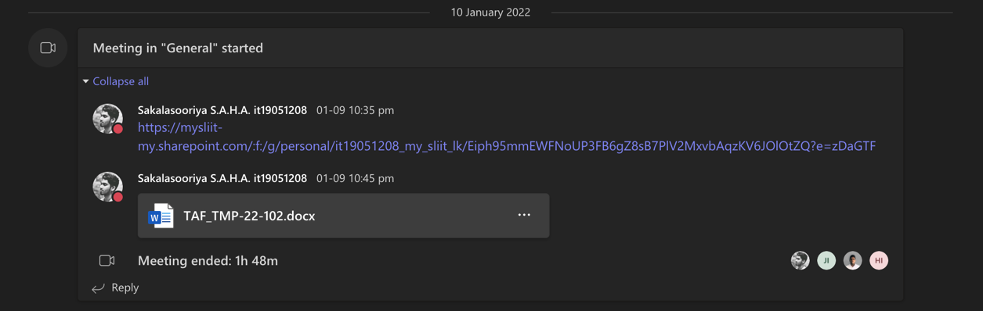

Figure 1.1.1. Topic assessment form preparation discussion meeting

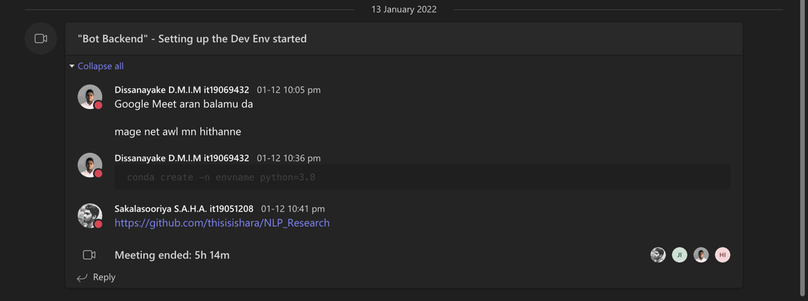

Figure 1.1.2. Chatbot backend design planning meeting

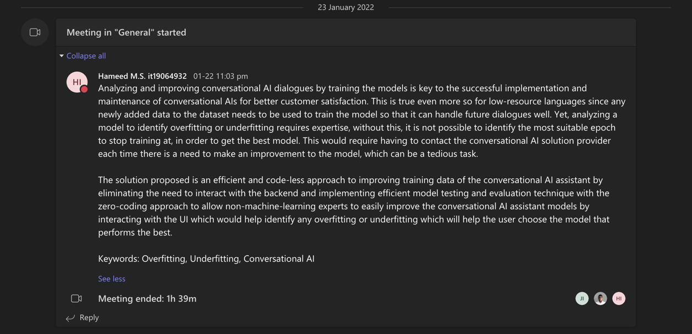

Figure 1.1.3. Charter document preparation team discussion - I

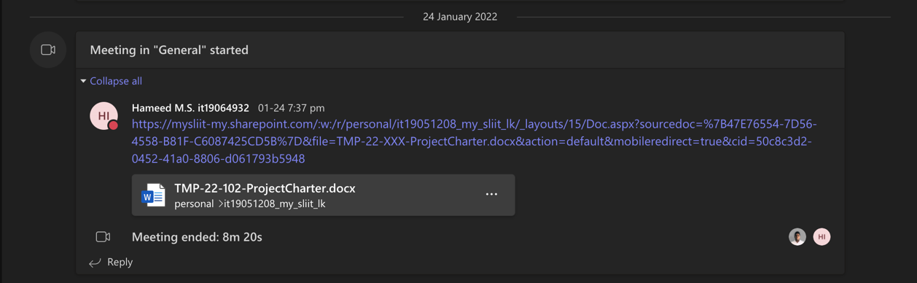

Figure 1.1.4. Charter document preparation team discussion - II

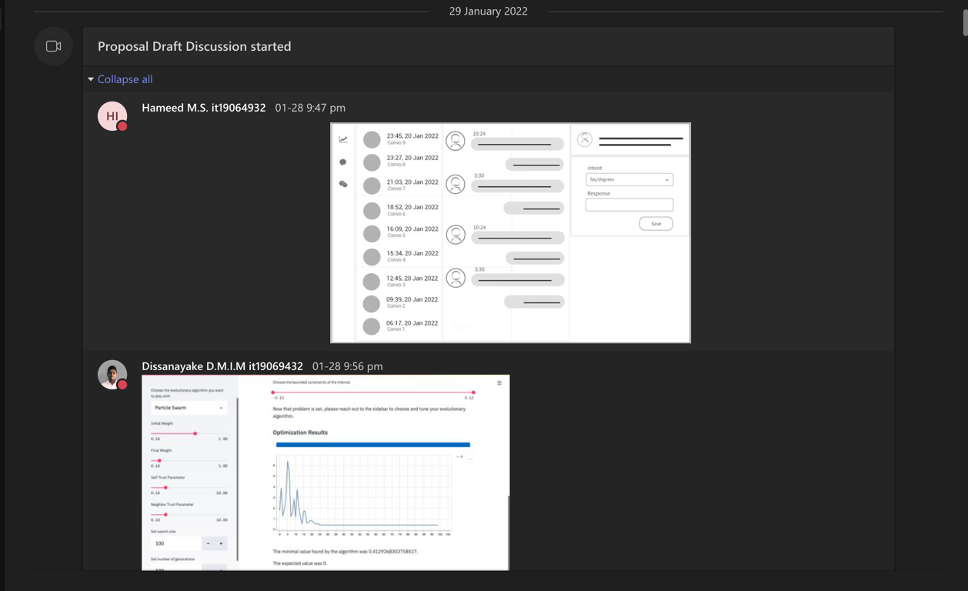

Figure 1.1.5. Research proposal draft preparation discussion meeting

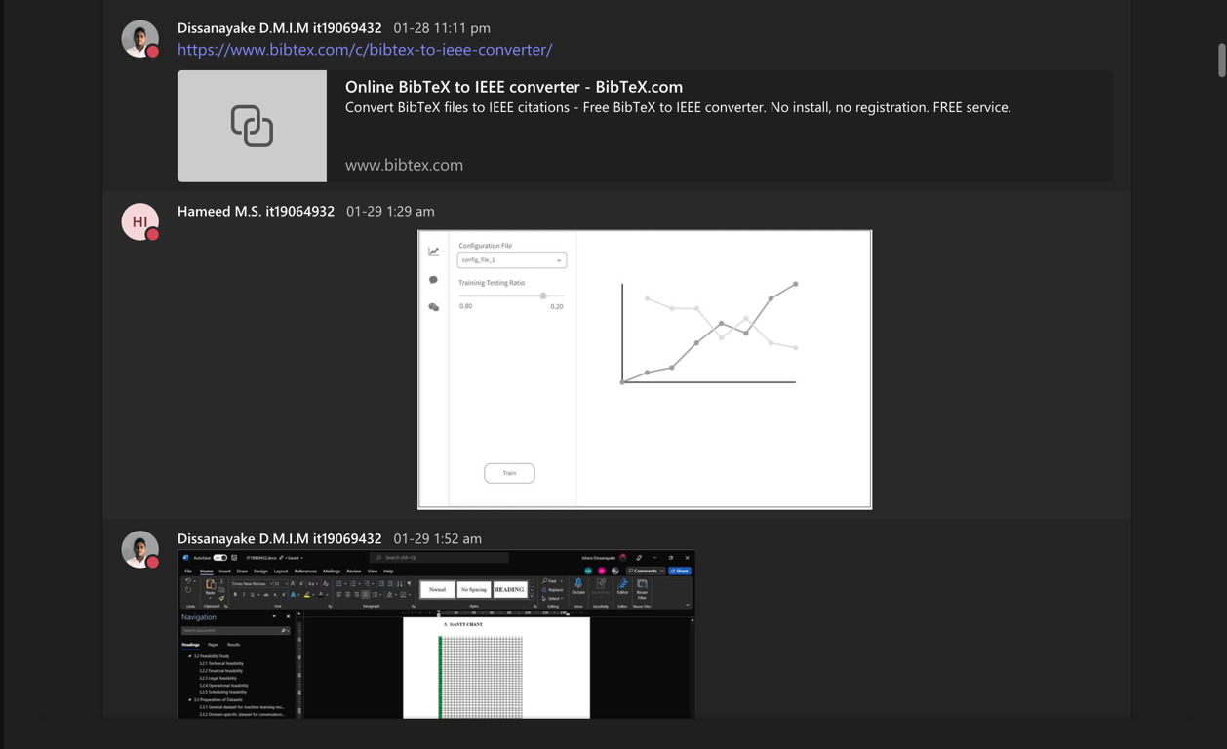

Figure 1.1.6. Files shared during the project proposal draft meeting - I

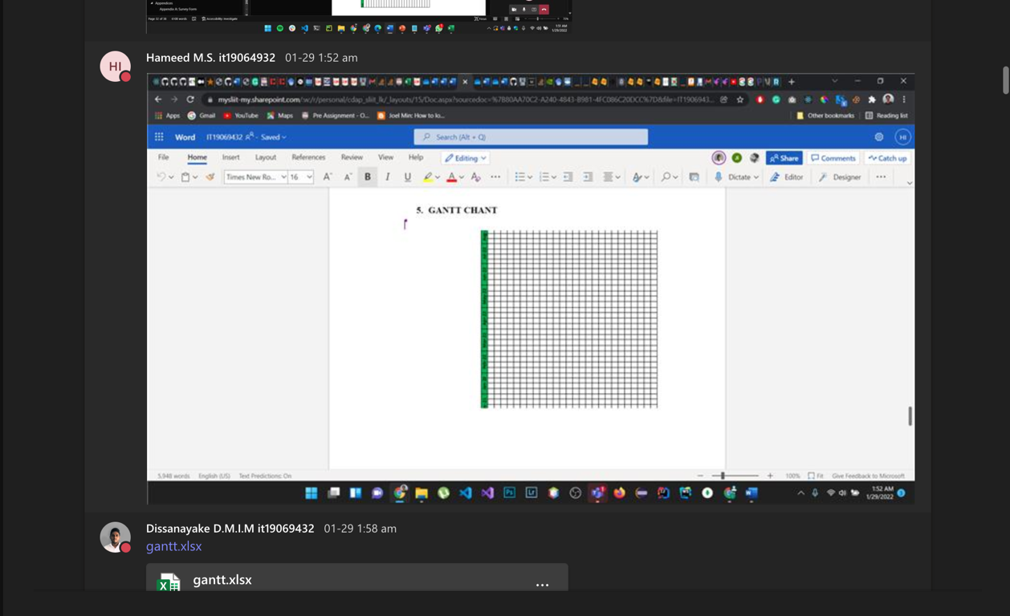

Figure 1.1.7. Gantt chart designed during the proposal draft discussion meeting - I

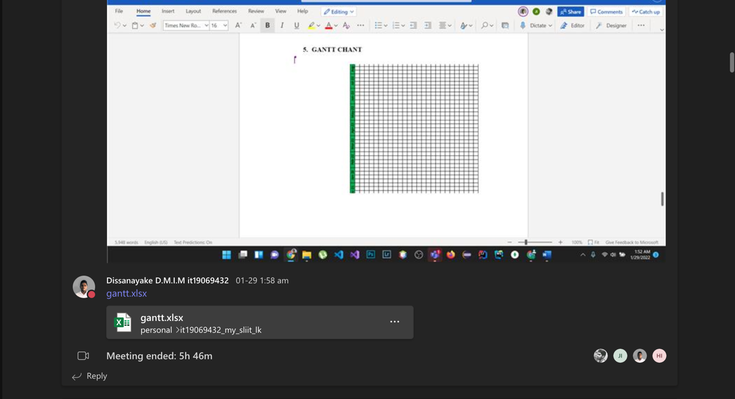

Figure 1.1.8. Gantt chart designed during the proposal draft discussion meeting - II

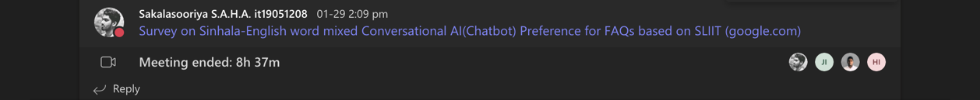

Figure 1.1.9. Survey planning and designing meeting

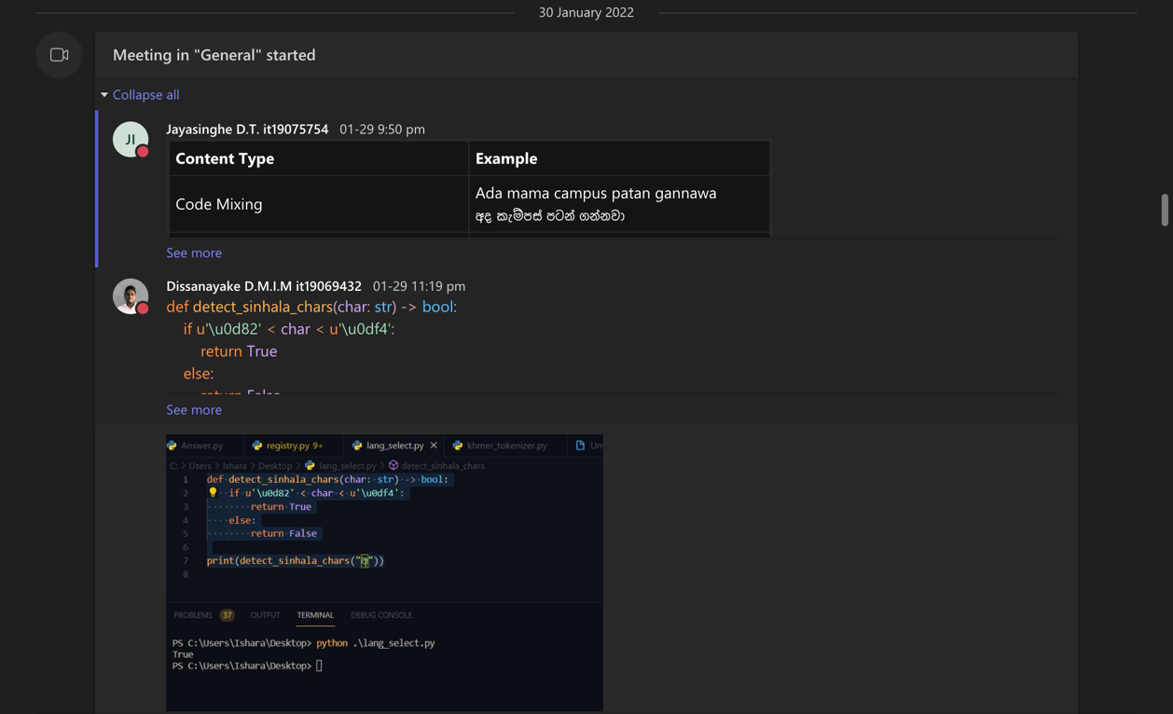

Figure 1.1.10. Files shared during the project proposal draft meeting - II

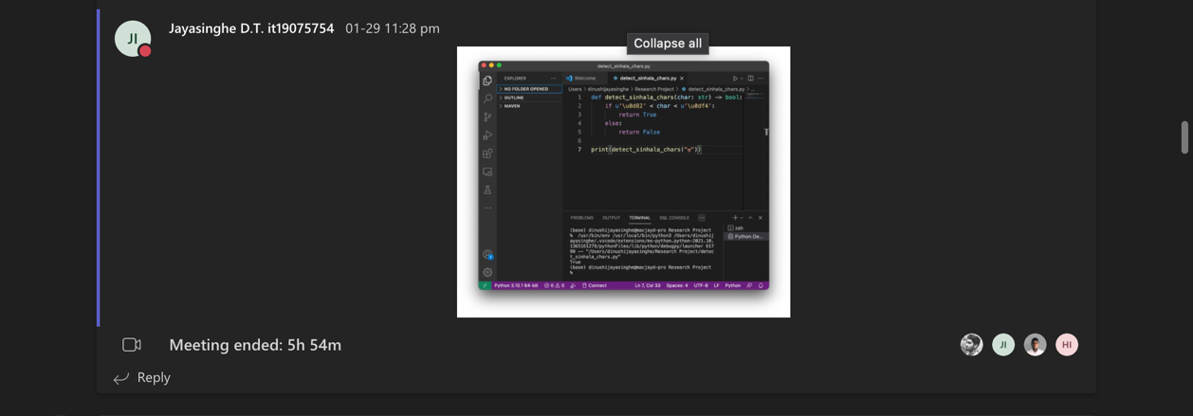

Figure 1.1.11. Files shared during the project proposal draft meeting - III

Figure 1.1.12. Ideas shared during proposal presentation planning discussion - I

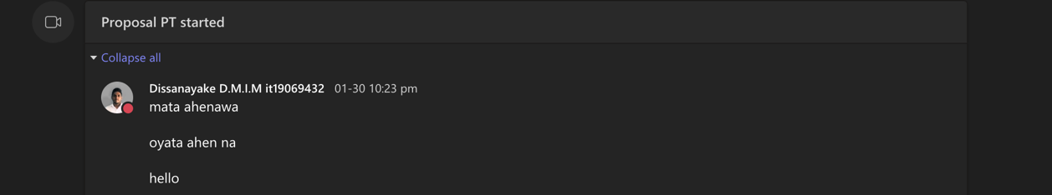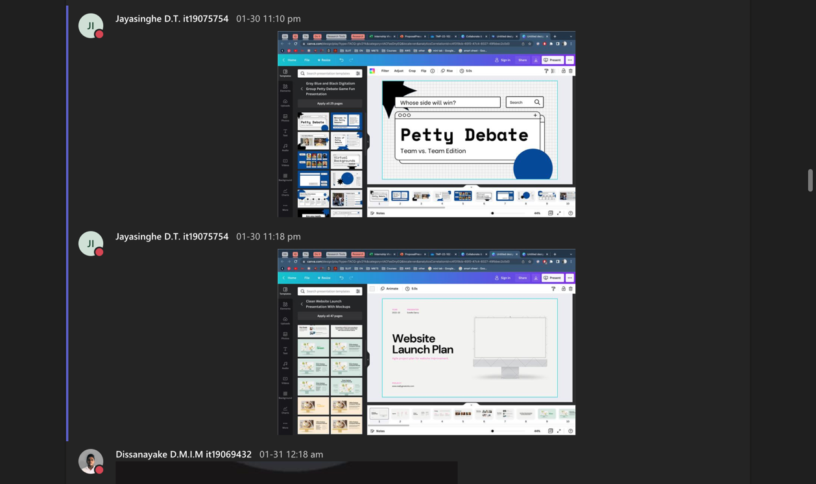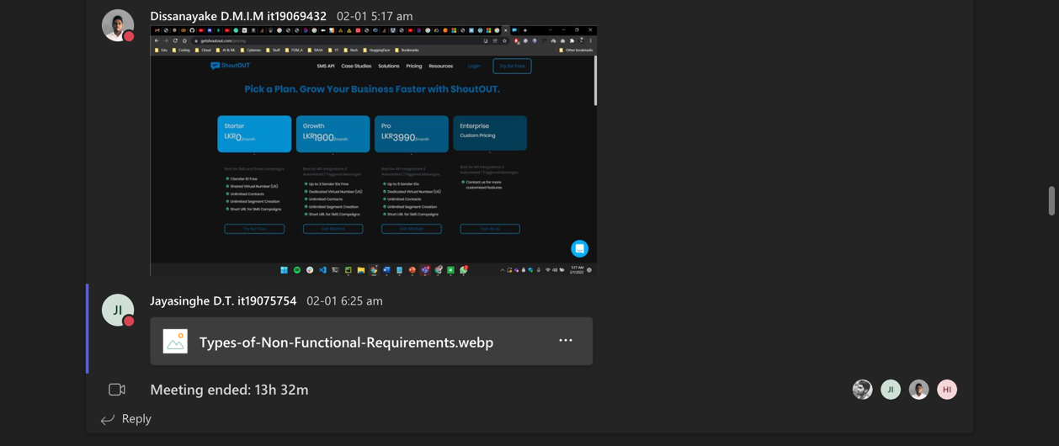

Figure 1.1.13. Ideas shared during proposal presentation planning discussion - II

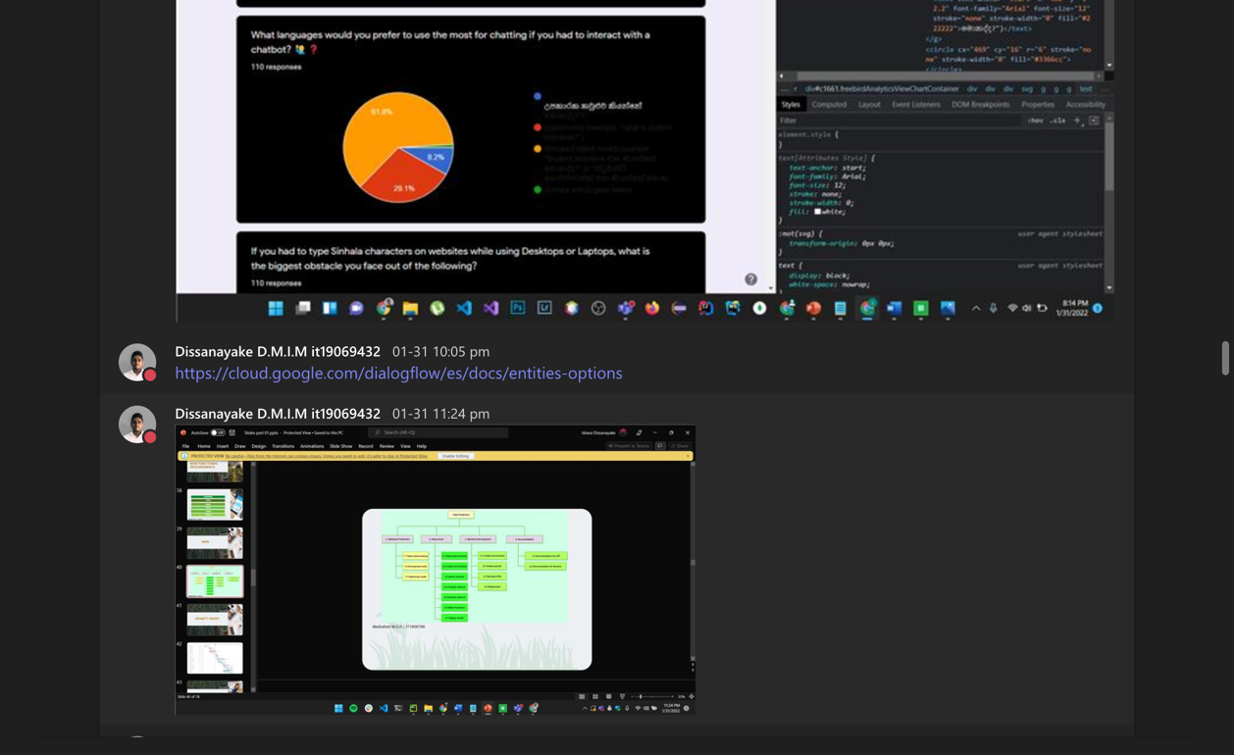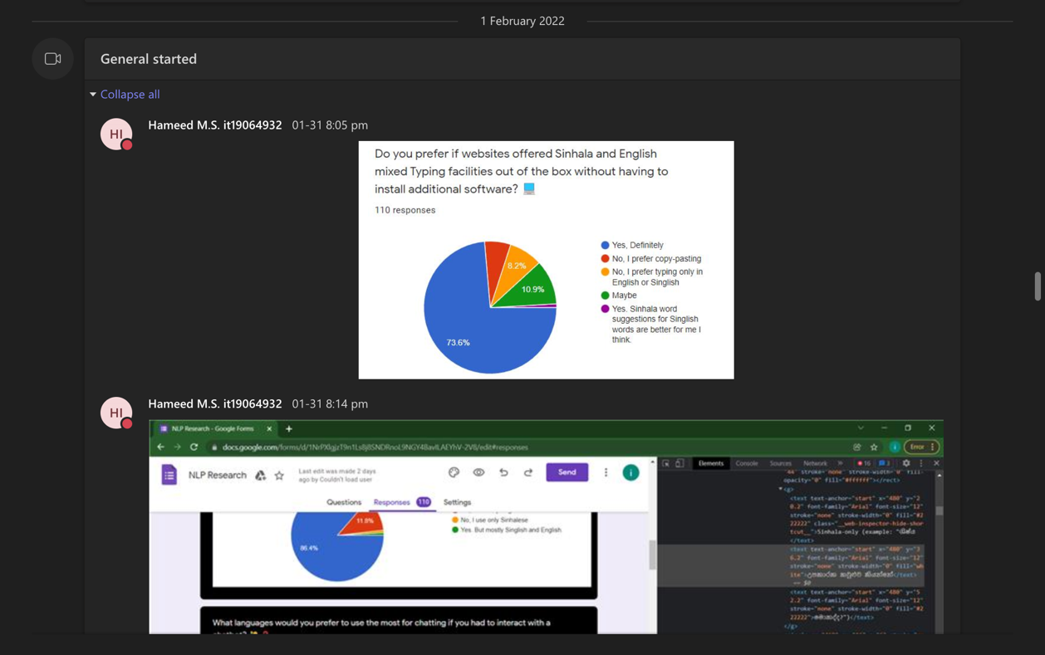

Figure 1.1.14. Proposal presentation demo meeting

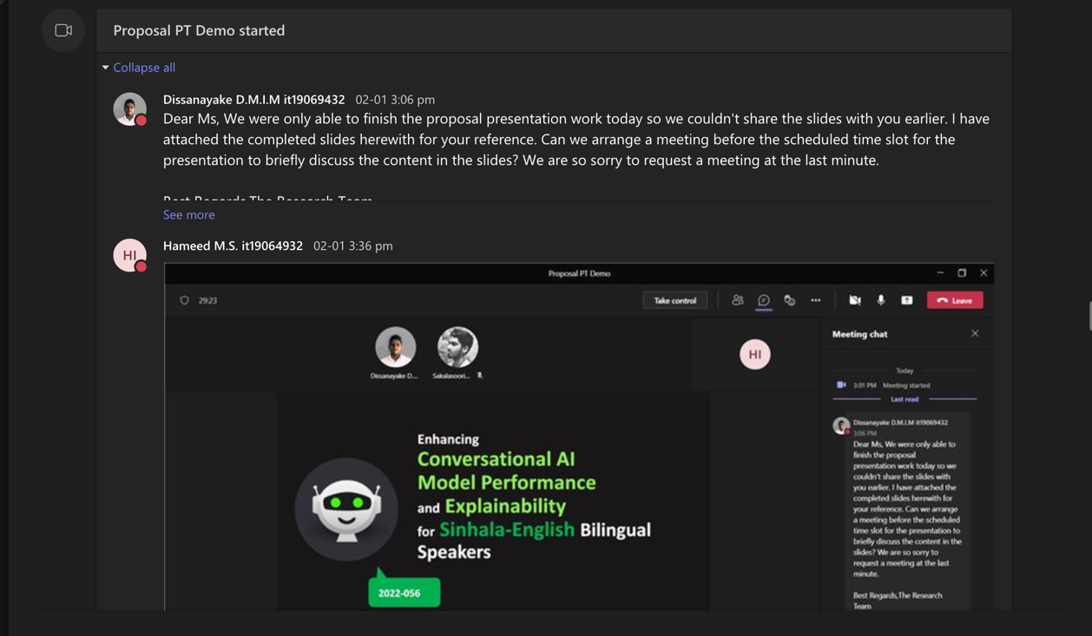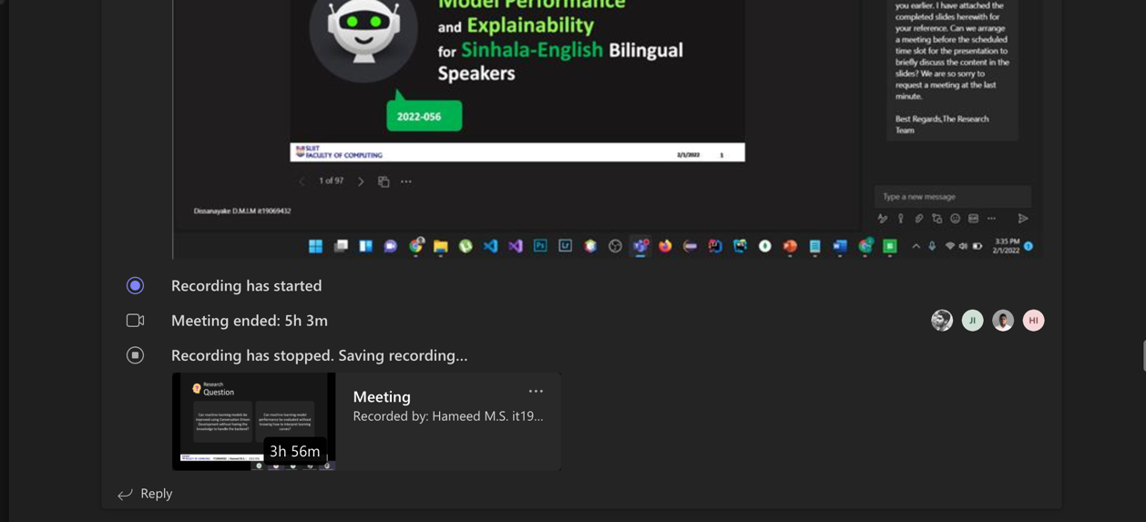

Figure 1.1.15. Proposal presentation last-minute preparation meetings

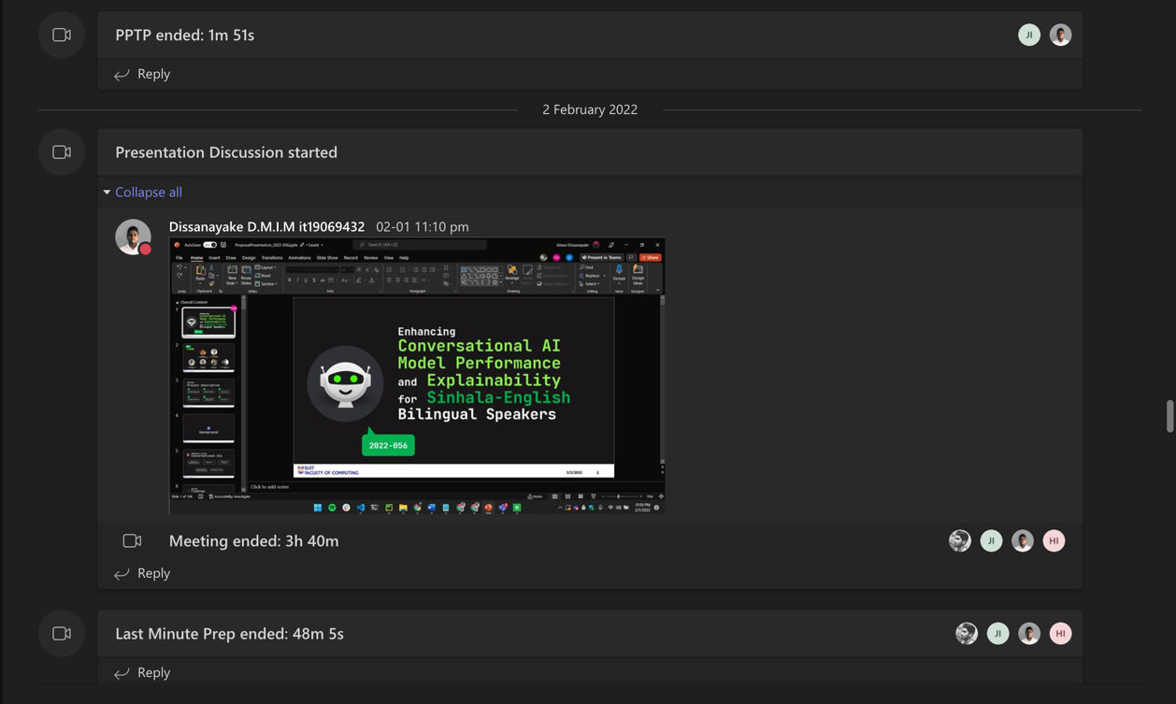

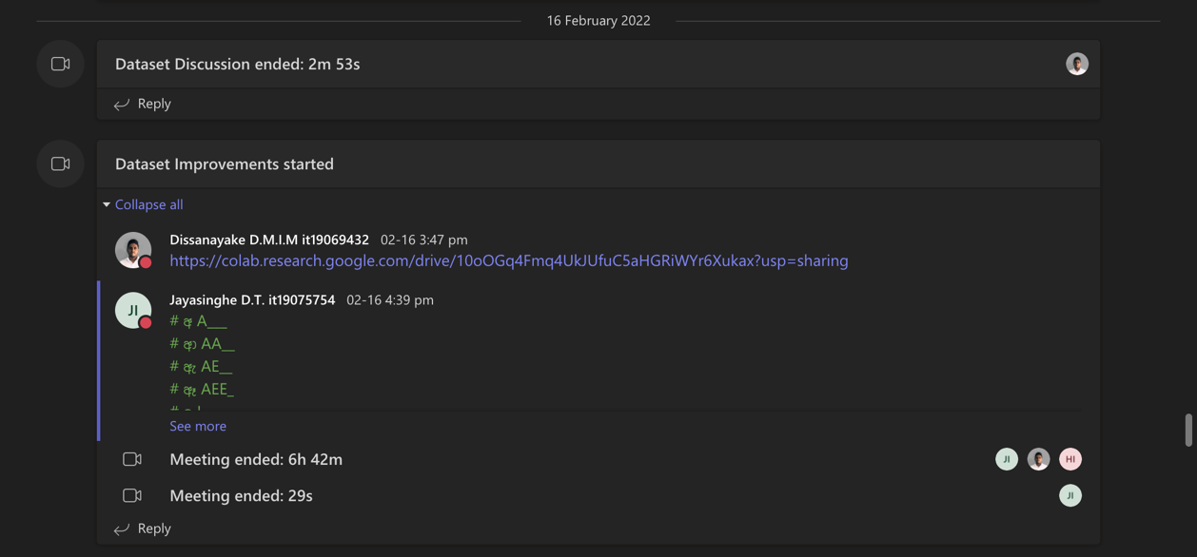

Figure 1.1.16. Initial dataset preparation planning discussion meeting

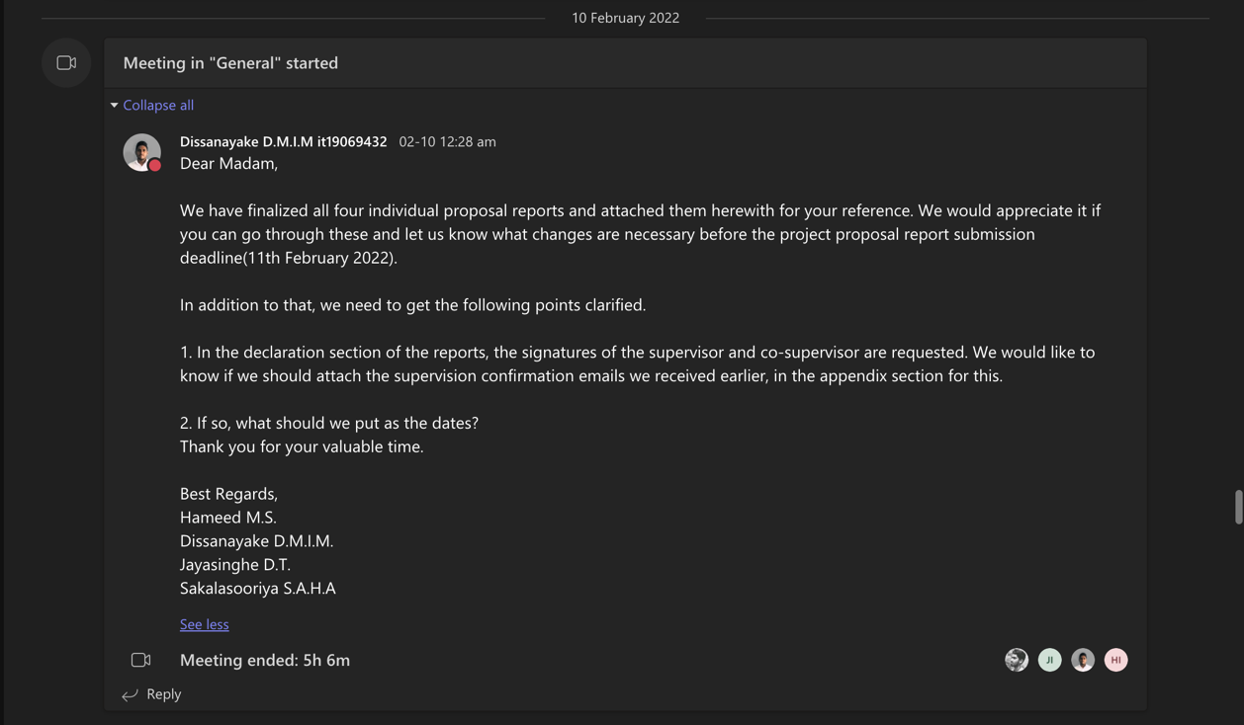

Figure 1.1.17. Proposal draft submission finalization meeting

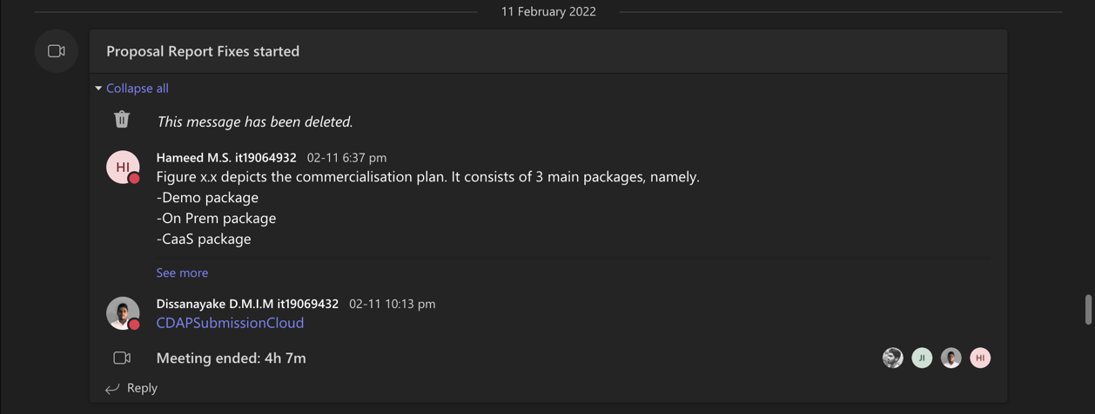

Figure 1.1.18. Proposal draft review and proofreading discussion

Figure 1.1.19. GitLab repository setting up meeting

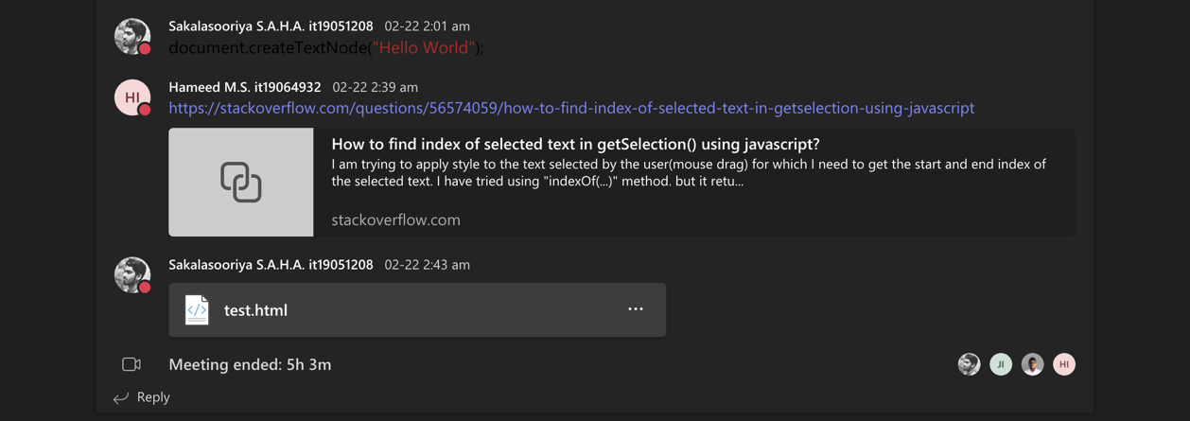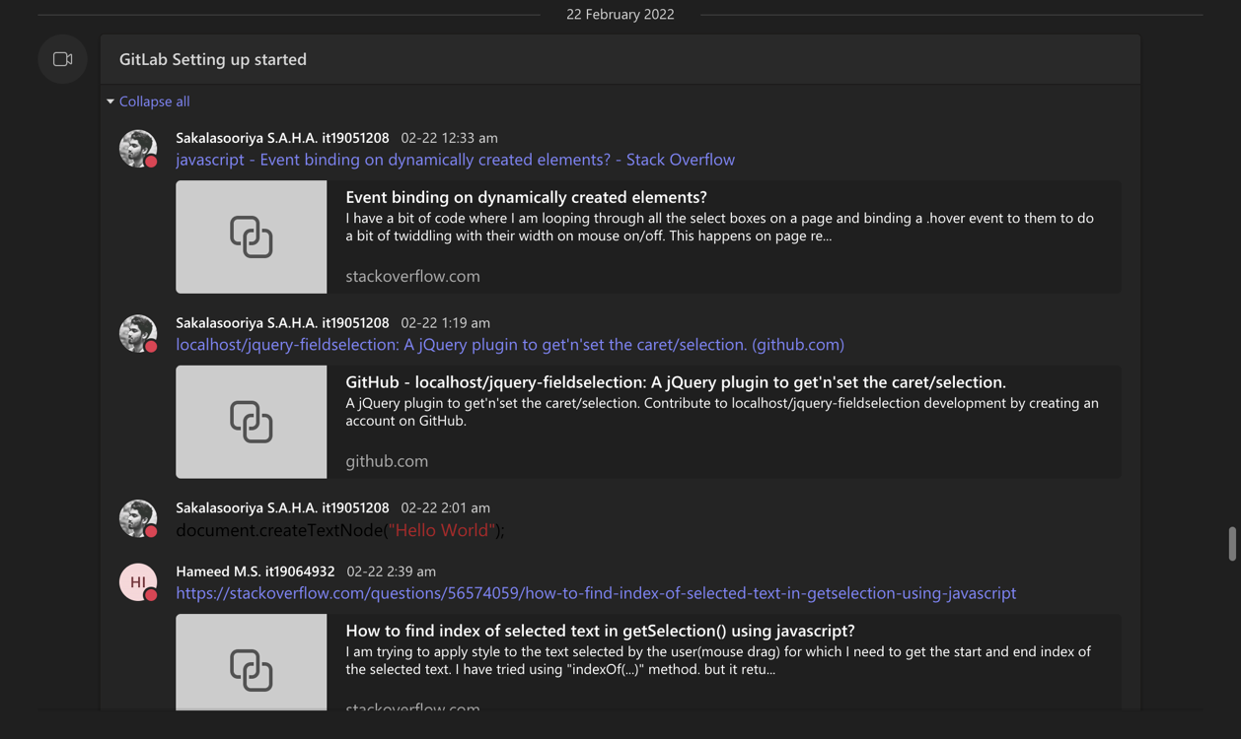

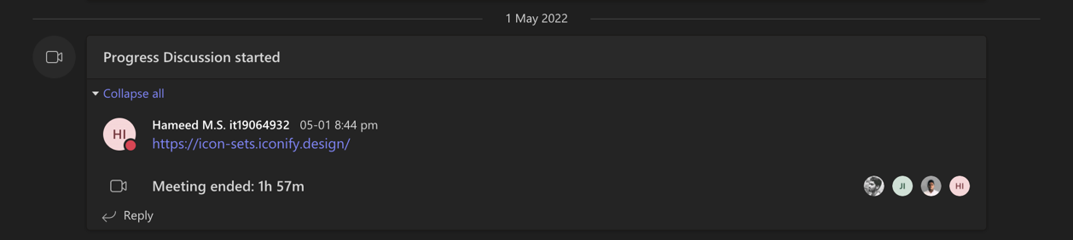

Figure 1.1.20. Research 50% progress discussion meeting with the four members

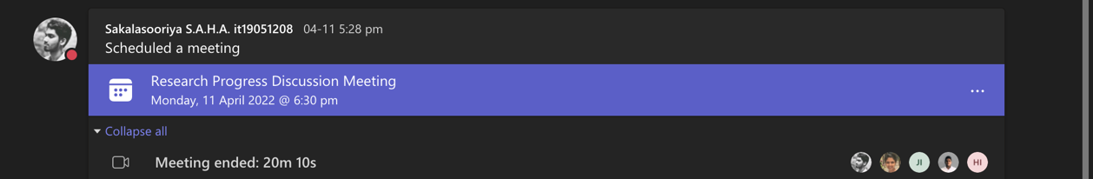

Figure 1.1.21. Research 50% progress discussion meeting with the team including supervisors

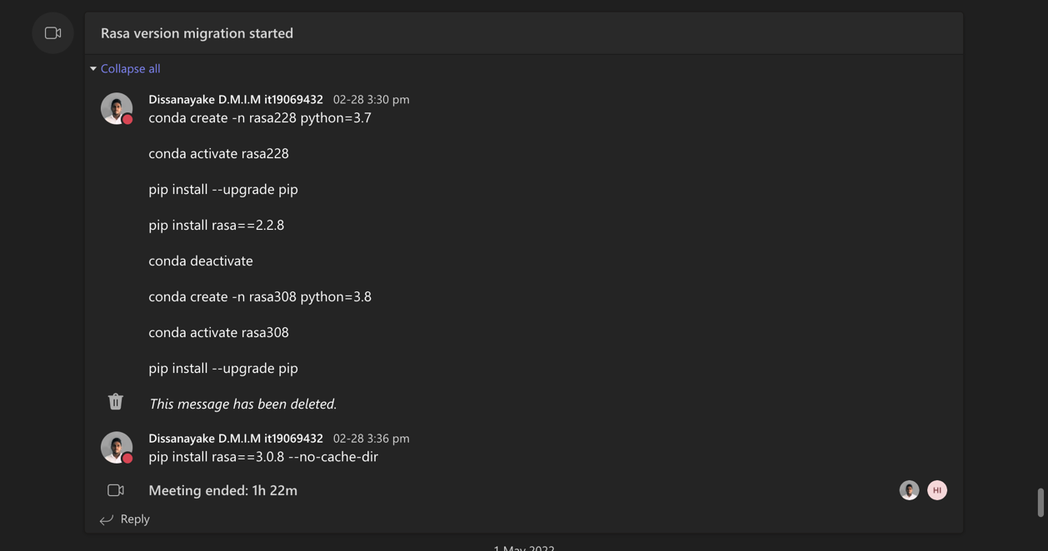Individual Teams meetings

Figure 1.1. 22. Rasa version migration meeting

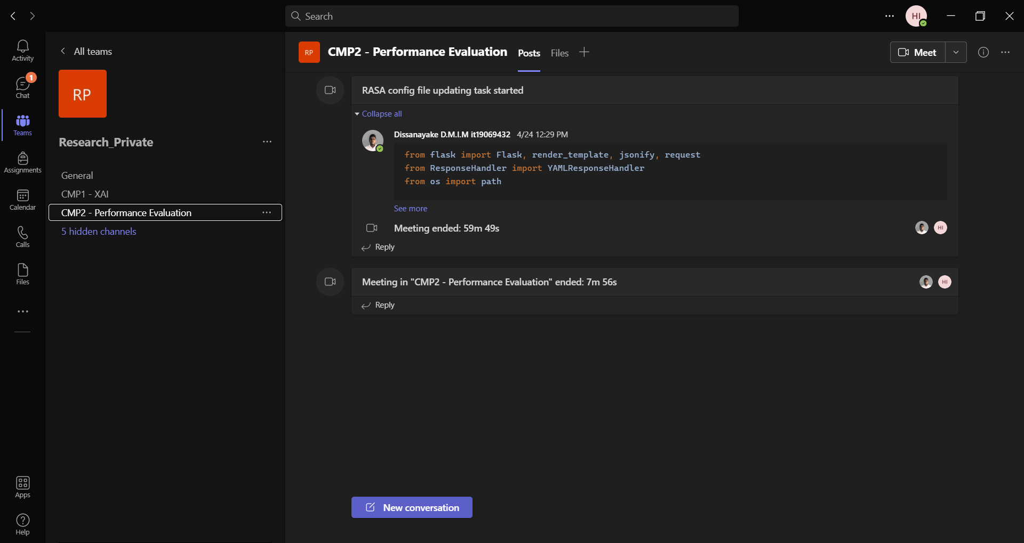

Figure 1.1. 23. Updating Rasa configuration file and discussing research component

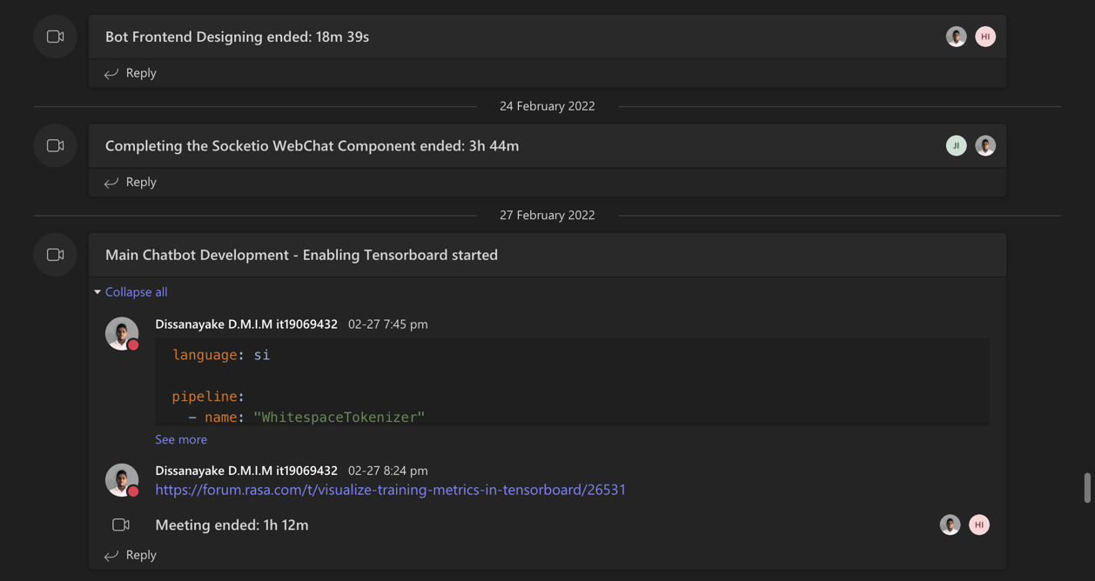

Figure 1.1. 24. Bot frontend design discussion meeting



Figure 1.1. 25. Discussion on enabling TensorBoard

## Conversations with the team

Following screenshots include all the conversations that took place via the Microsoft Teams channel, created for the Research project team.

Group conversations

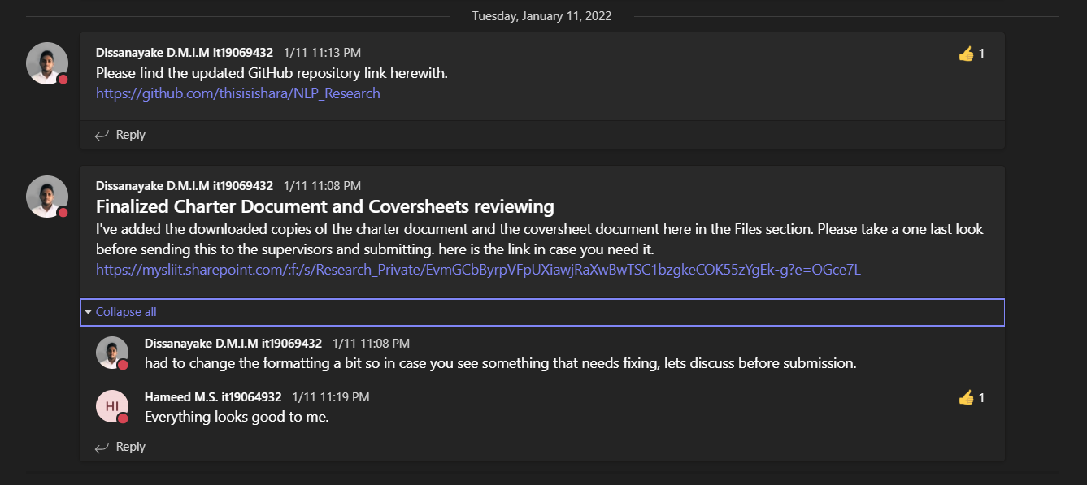

Figure 1.2. 1. Charter document review conversation

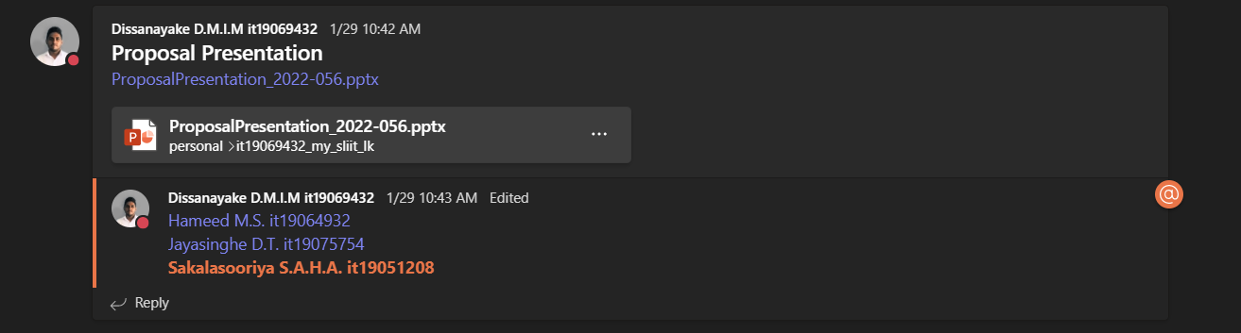

Figure 1.2. 2. Initial proposal presentation sharing and discussion

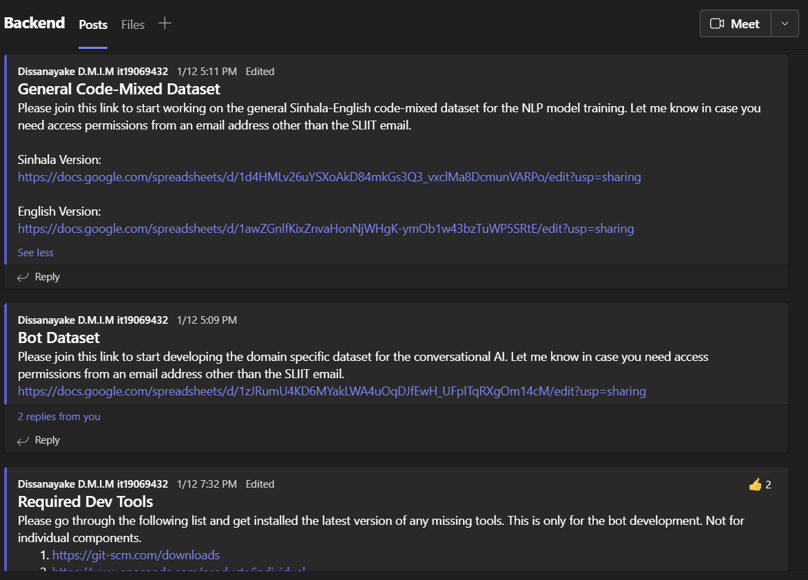

Figure 1.2. 3. Discussion / Resources sharing on dataset and development tools

Individual conversations / replies

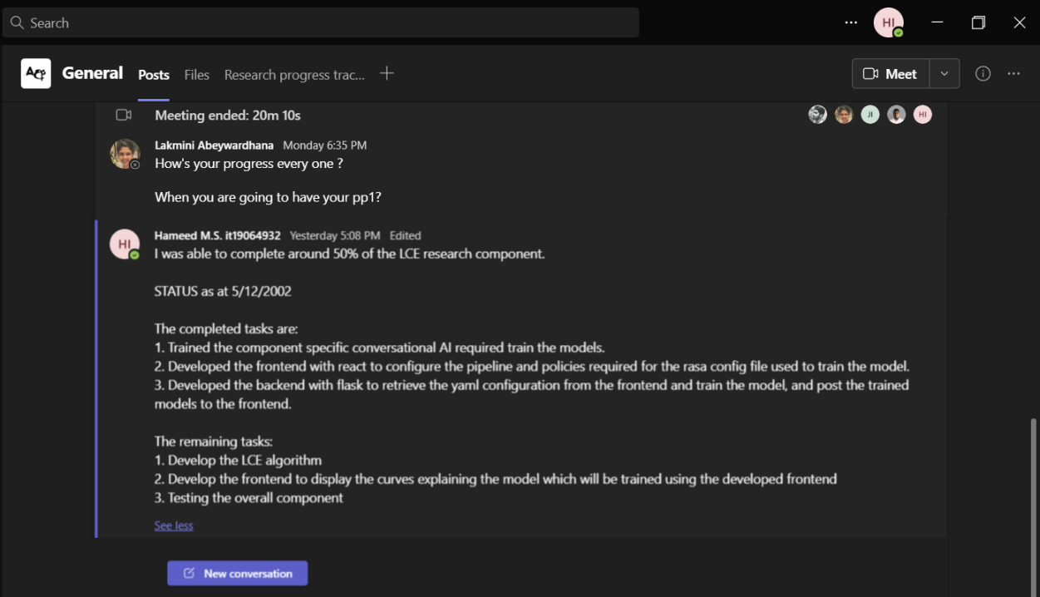

Figure 1.2. 4. Project 50% status update given to supervisor

## MS Teams Planner Project Backlog

Following screenshots include all the project backlogs created using Boards in Microsoft Teams Planner.

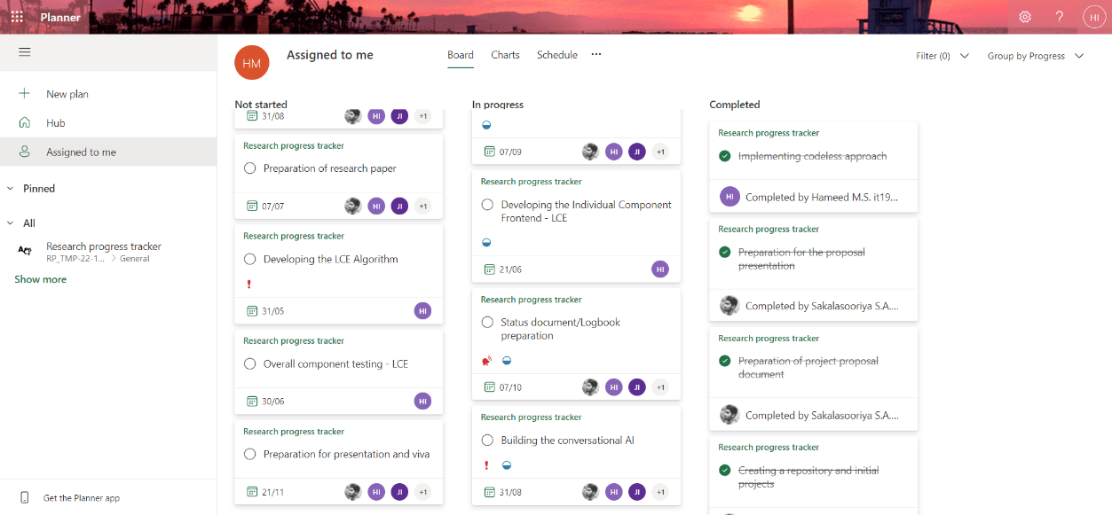

Figure 1.3. 1. Project backlog with individually assigned tasks to IT19064932

## MS Teams Planner Charts

Following screenshots include all the charts generated by Microsoft teams planner

Group charts

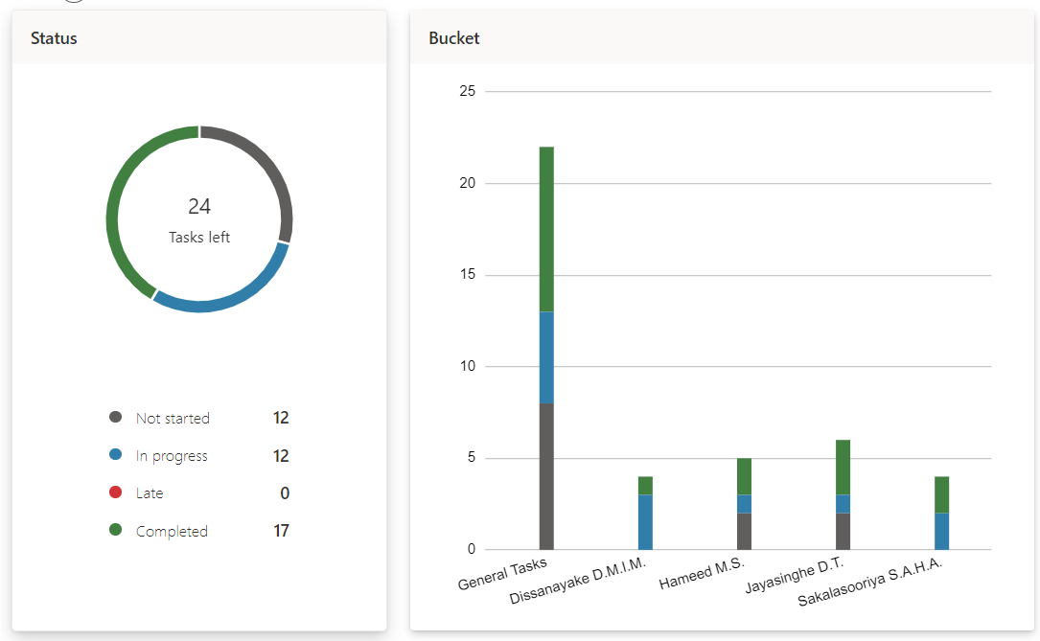

Figure 1.4.1. Number of total tasks and tasks assigned to each member

Individual charts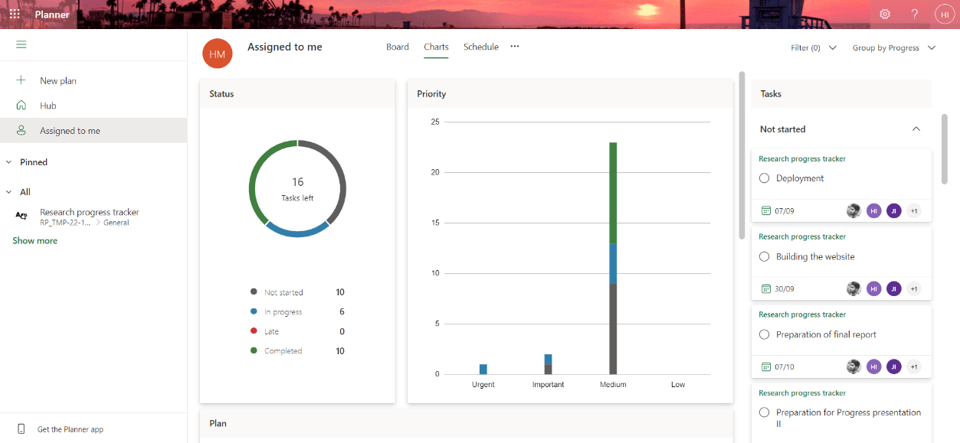

Figure 1.4.2. Number of tasks assigned to IT19064932 along with priority

# Git Logs

## GitLab Branch

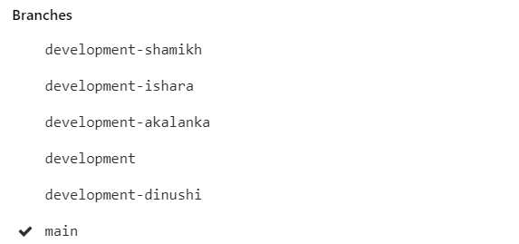The following screenshot shows the Gitlab branches.

Figure 2.1. 1. GitLab branches created

## GitLab Contributions

The following screenshots include some of the contributions done on Gitlab.

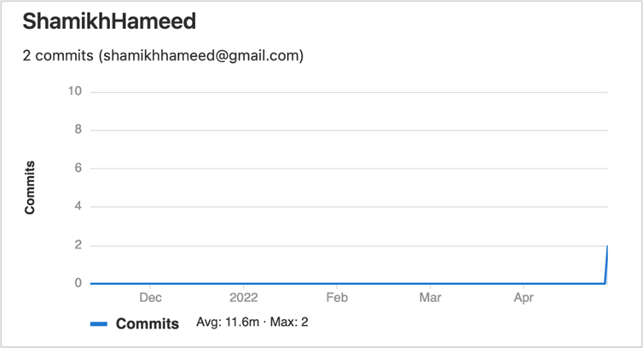

Figure 2.2.. GitLab commits done over time

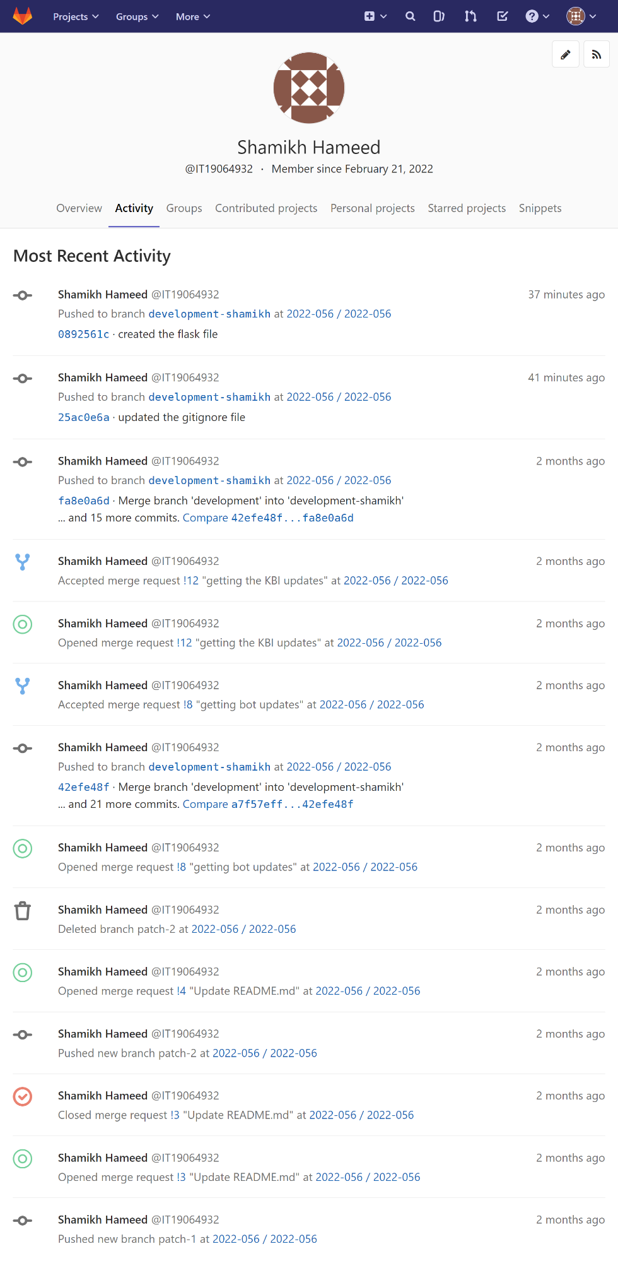

Figure 2.2. 2. GitLab recent activity

## Individual GitHub Repositories

The following screenshots include some of the contributions done on GitHub.

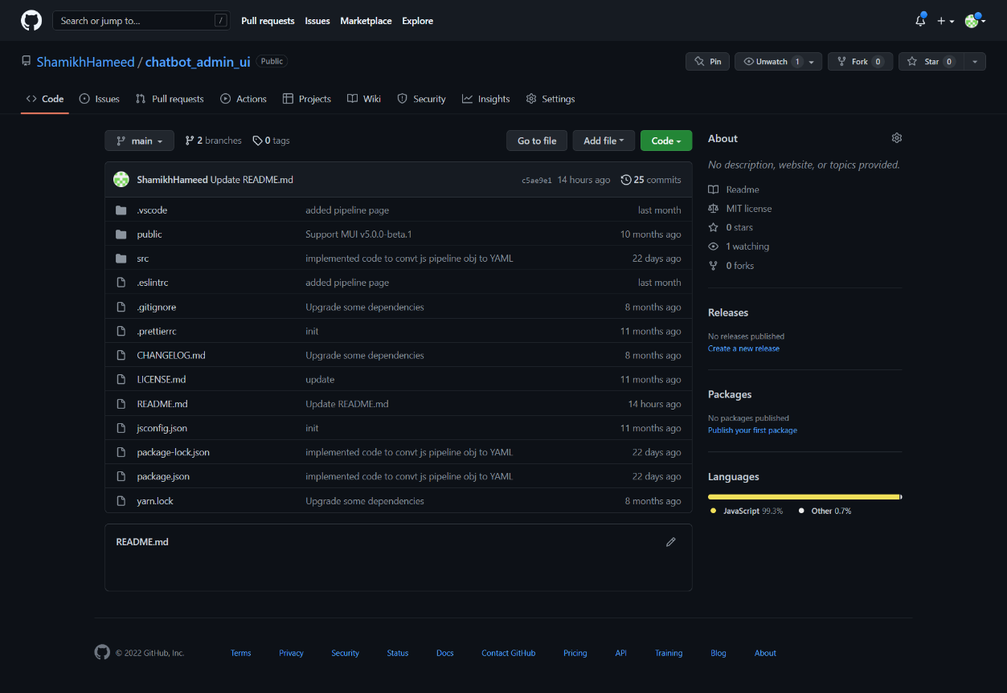

Figure 2.3. 1.GitHub repository used to develop the frontend of the component. Link: <https://github.com/ShamikhHameed/chatbot_admin_ui>

# Emails

The following screenshots include some of the emails sent to the supervisors in charge.

## Supervision requesting and confirmation emails

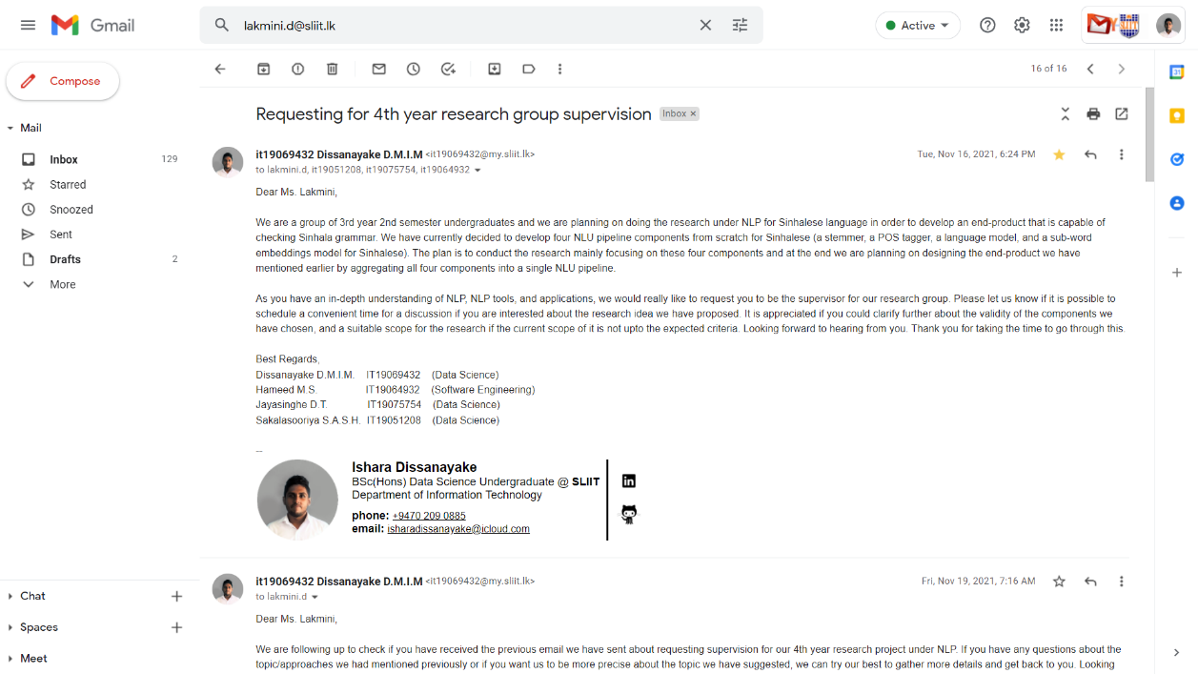

Figure 3.1. . Research supervision request email

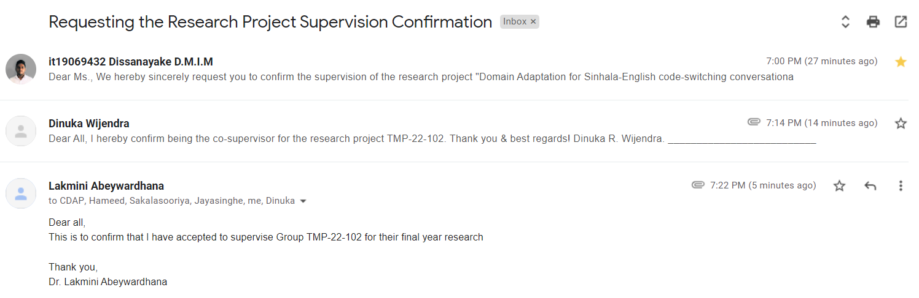

Figure 3.1. . Research project supervision confirmation

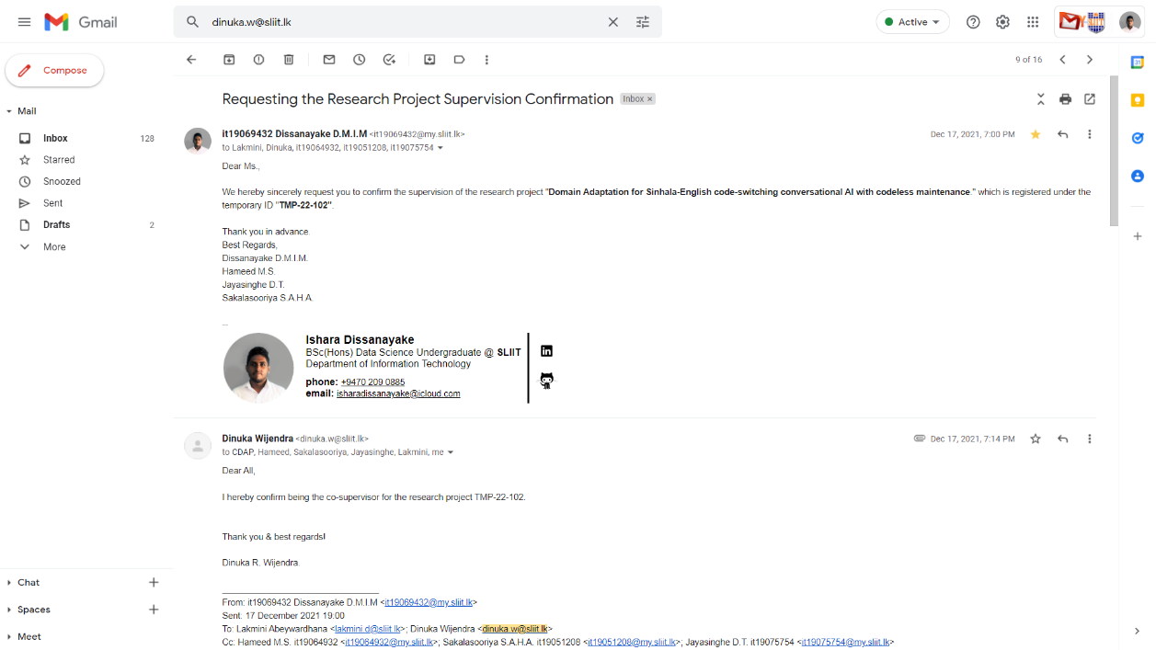

Figure 3.1. Research project co-supervision request and response

## Topic discussion meeting scheduling

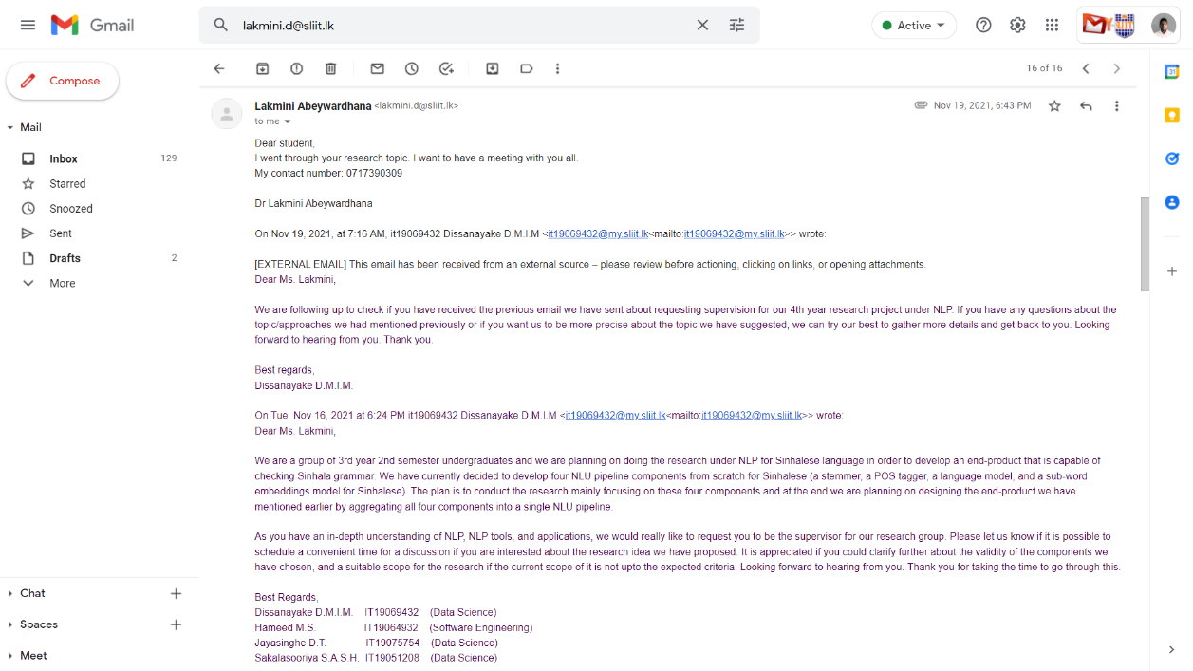

Figure 3.2. . Topic discussion meeting scheduling - I

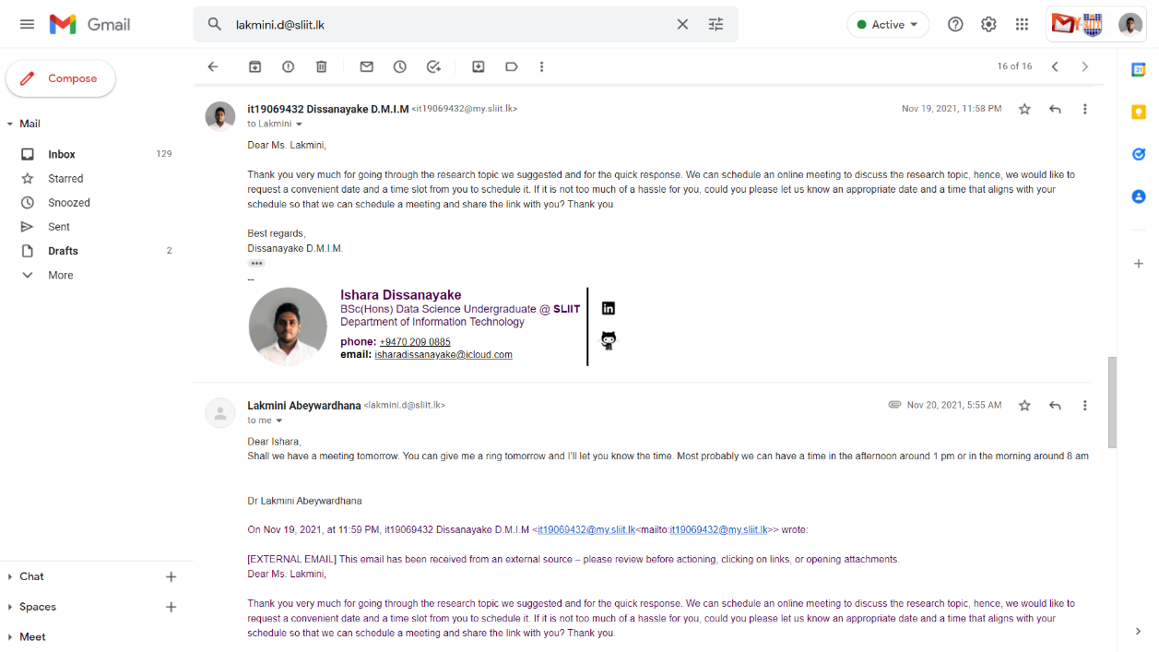

Figure 3.2. Topic discussion meeting scheduling - II

## Research proposal draft review requesting emails

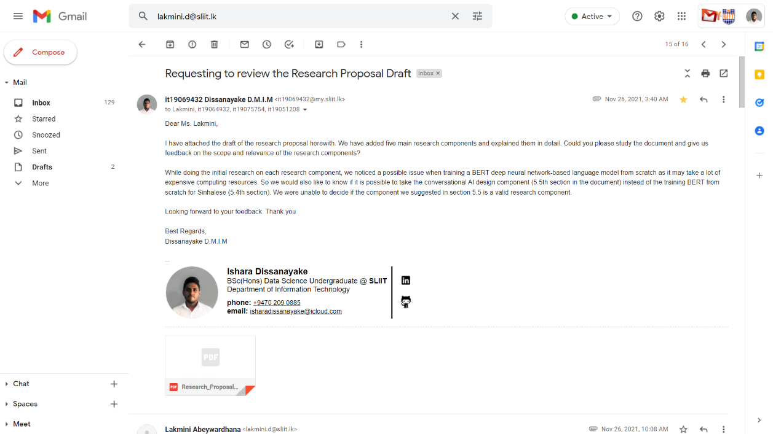

Figure 3.3. . Proposal drafts review request

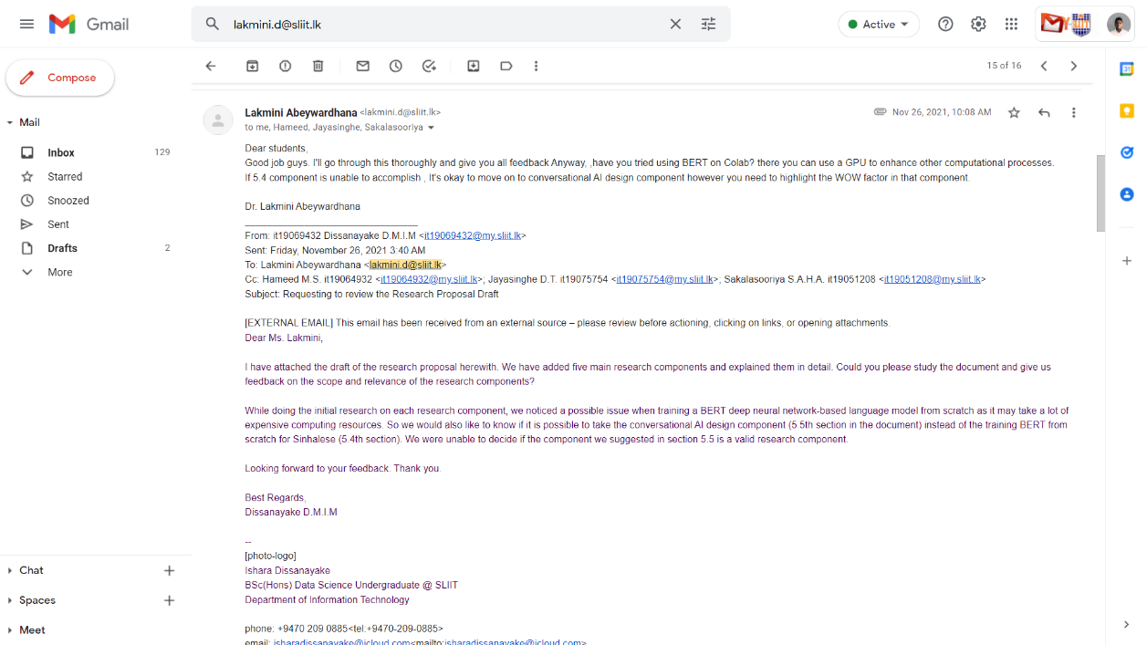

Figure 3.3. . Reply of the supervisor on proposal drafts review request

## Progress discussion meeting scheduling

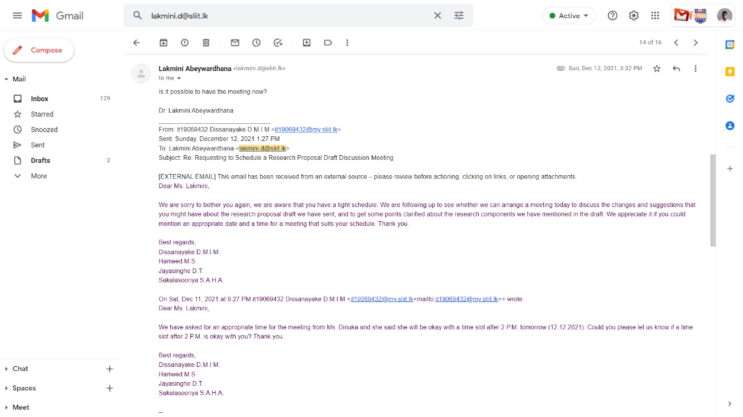

Figure 3.4. . Research progress discussion meeting request

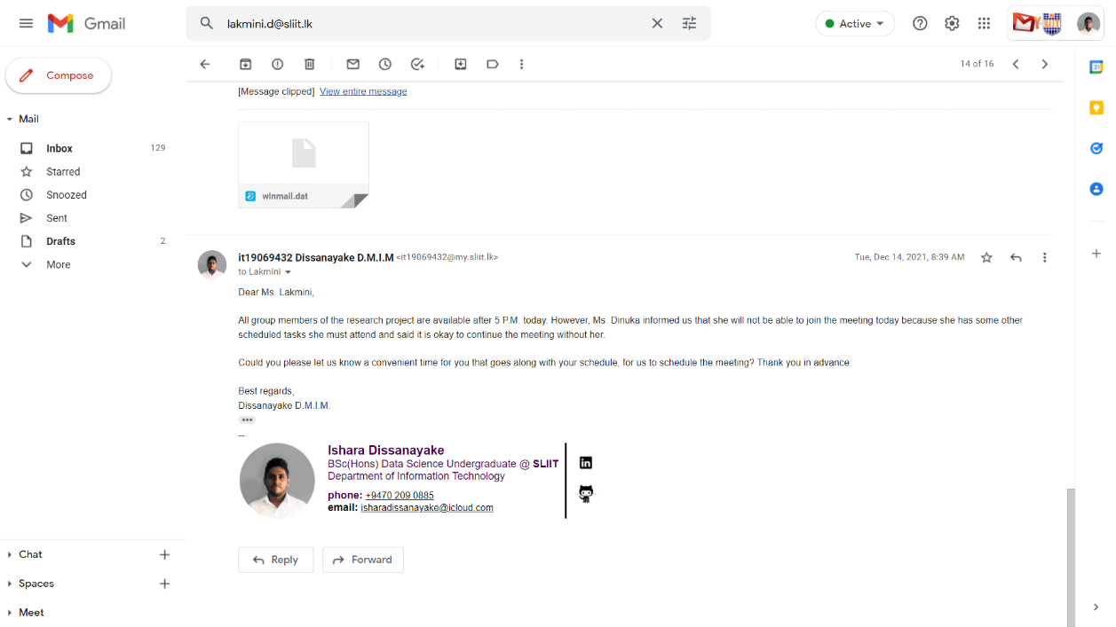

Figure 3.4. . Reply for the research progress discussion meeting request

## Topic assessments form review request

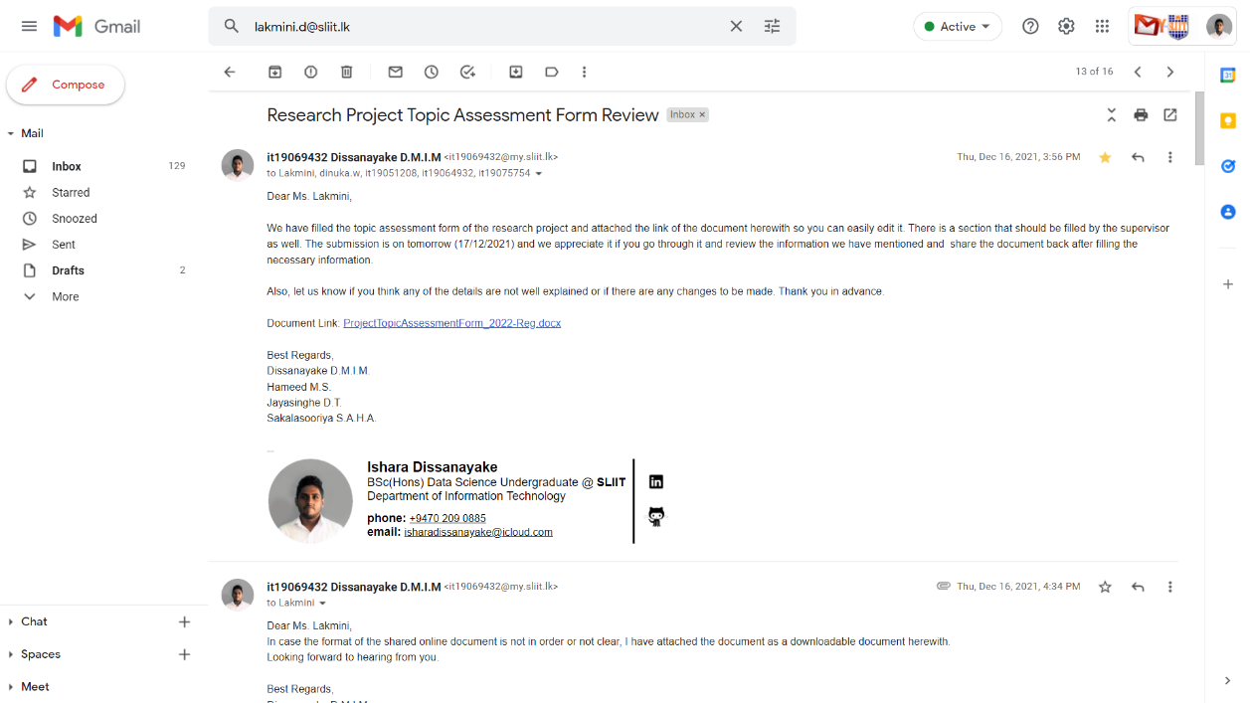

Figure 3.5. . Topic assessment form review request - I

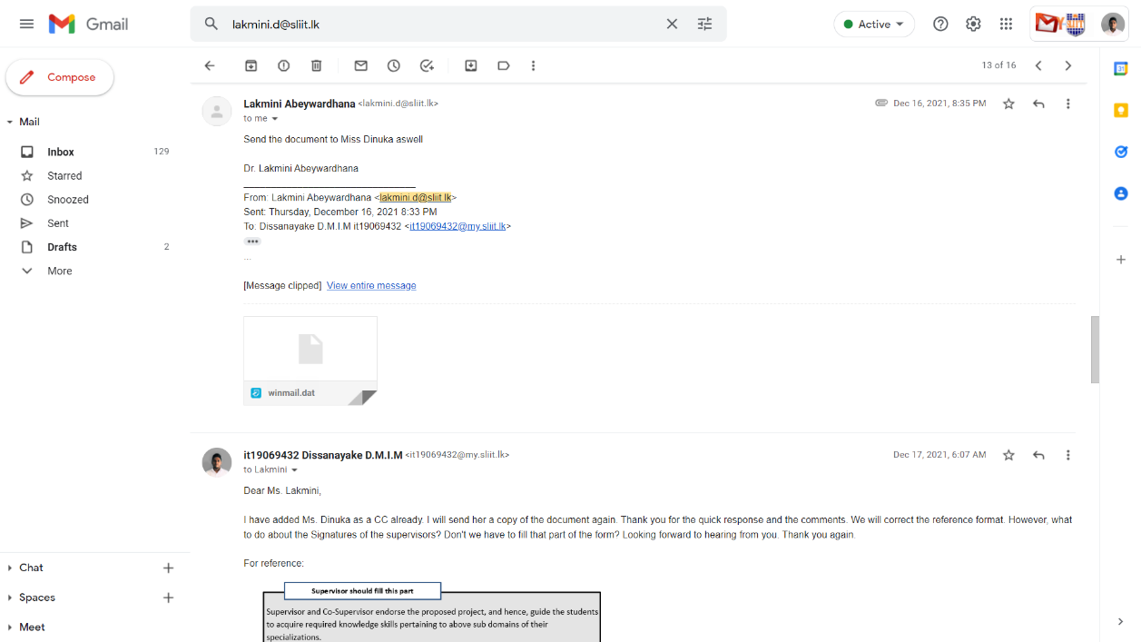

Figure 3.5. . Topic assessment form review -II

## Research component changes review request

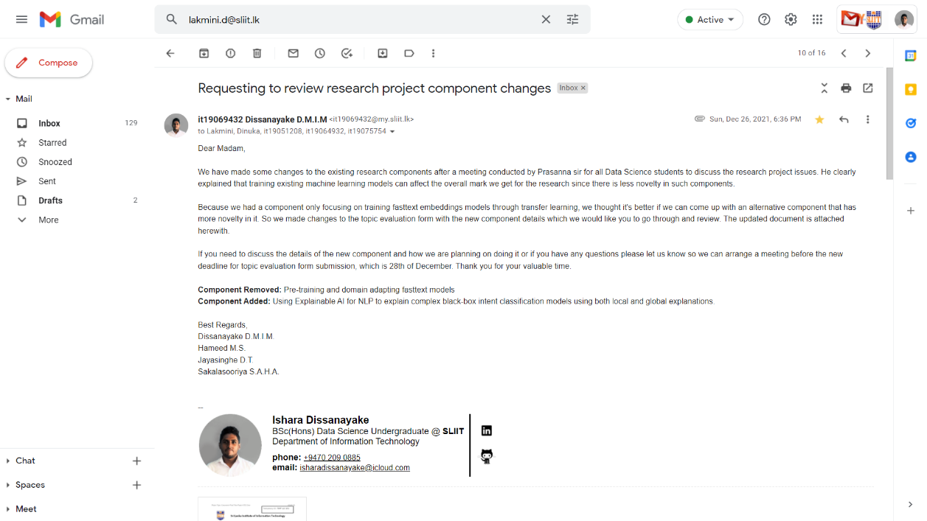

Figure 3.6. . Research component/component objective changes review request

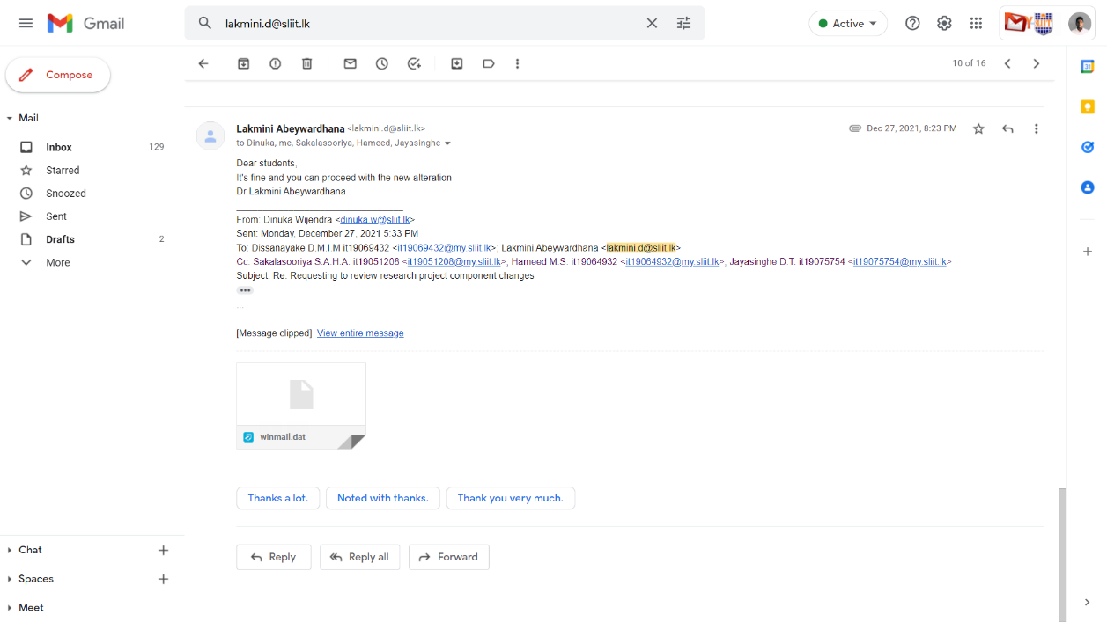

Figure 3.6. . Component changes approval of the supervisor

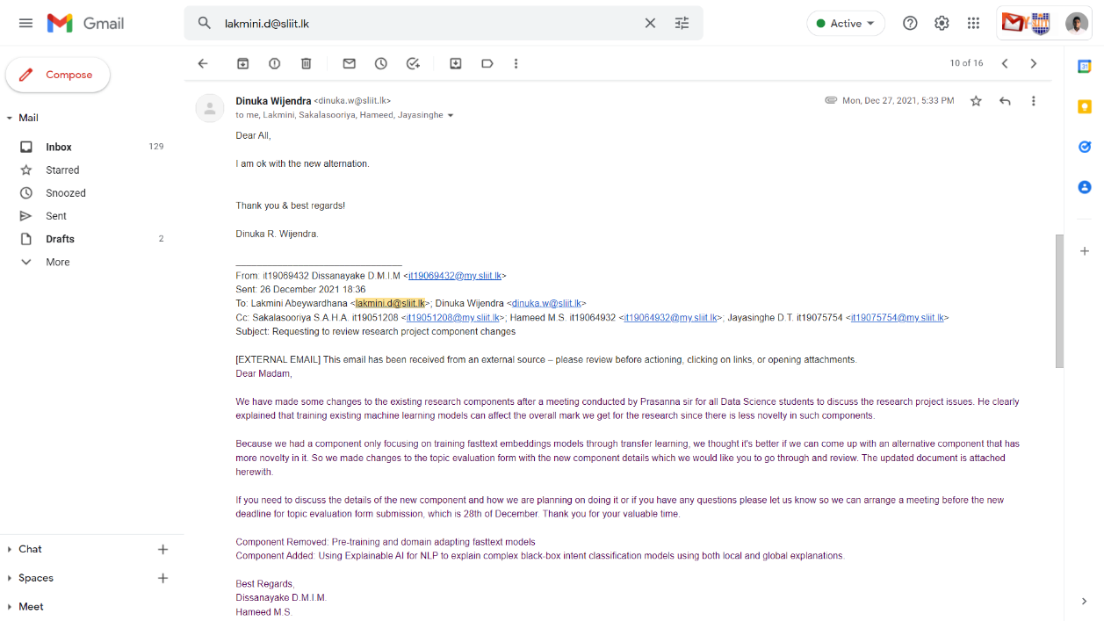

Figure 3.6. . Component changes approval of the co-supervisor

## Topic changes review request after panel evaluation was done

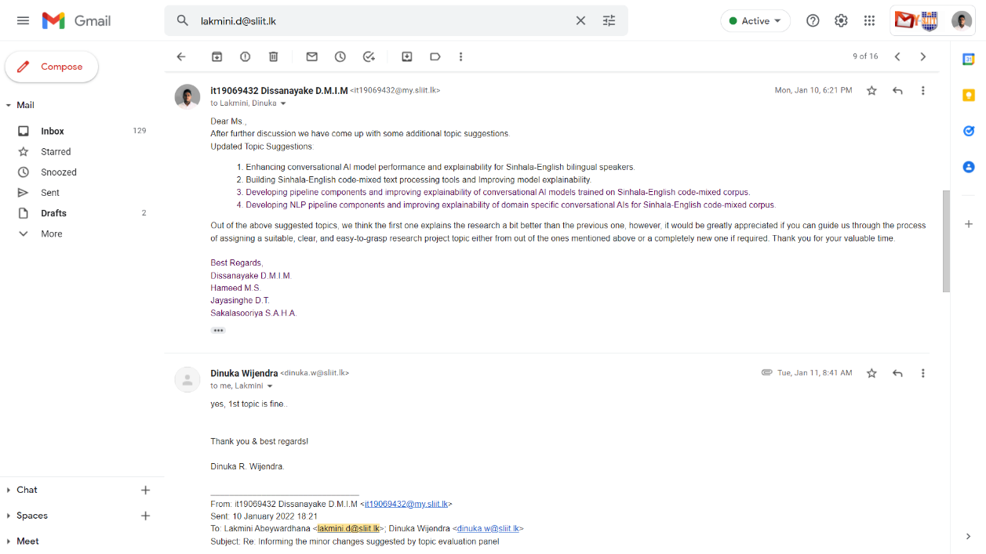

Figure 3.7. . Topics suggested by the members due to the suggestion made by the panel

## Individual project proposal documents review request

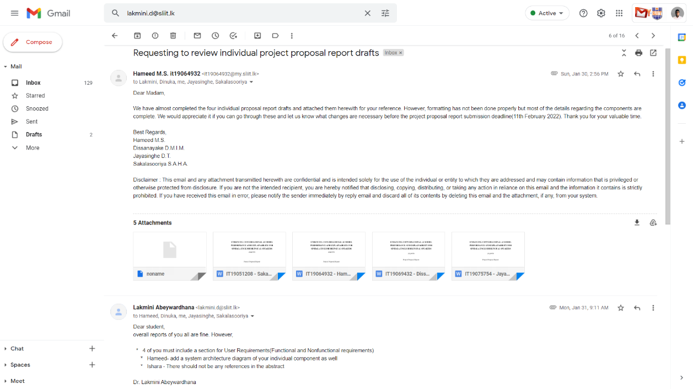

Figure 3.8. . Individual proposal draft review request

## Sharing the updated proposal presentation slides deck

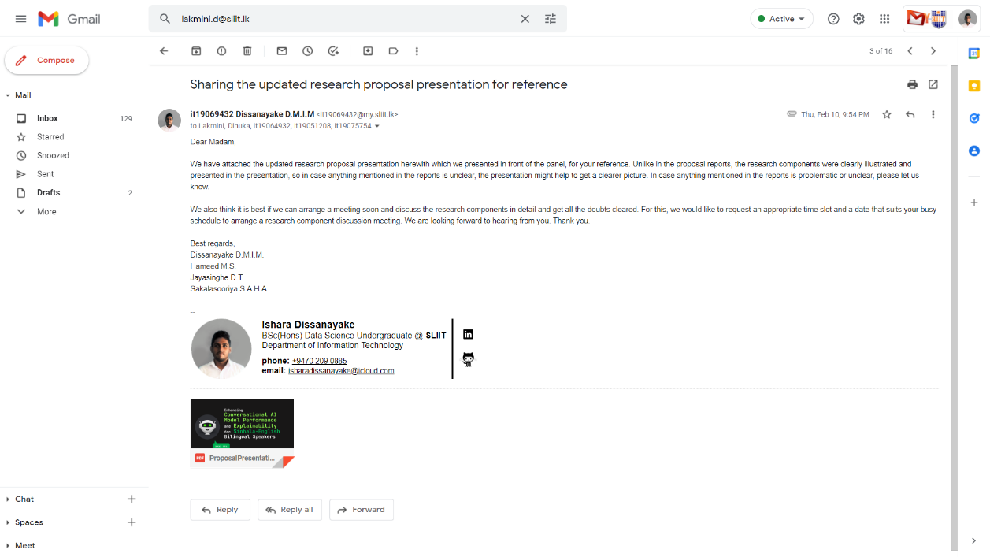

Figure 3.9. . Sharing the updated proposal slides deck

## Research progress discussion meeting before progress presentation – I

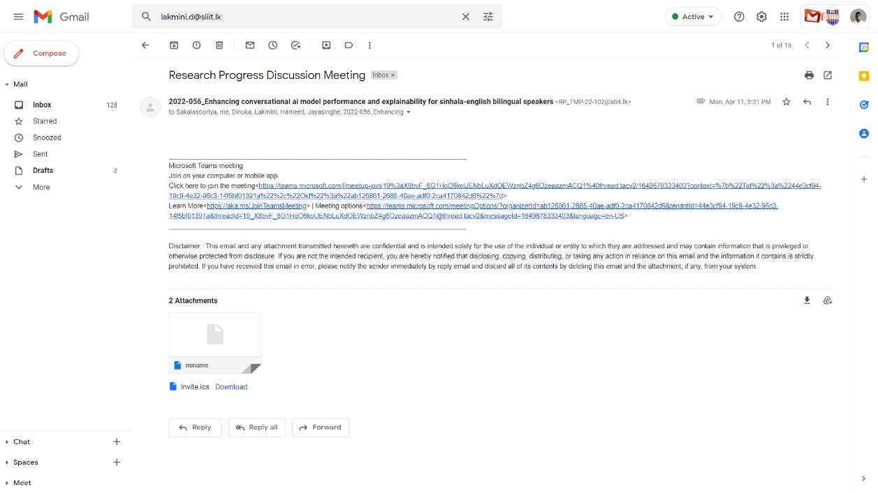

Figure 3.10. . 50% progress discussion meeting scheduling

# Gantt chart comparison

Figure 4.1 breaks down all tasks of this individual research component under 5 main tasks. Deployment is done at the end by integrating all four research components.

Figure 4.. Predicted Gantt chart vs actual completion comparison



Legend: ■ Predicted time

■ Actual spent time

■ Remaining time for general tasks

■ Remaining time for individual tasks

# Work breakdown and task status

Figure 5.1 illustrates the work breakdown structure and the completion status of each task within the individual research component.

Figure 5. . Work breakdown structure, completed, on-going and pending task indications

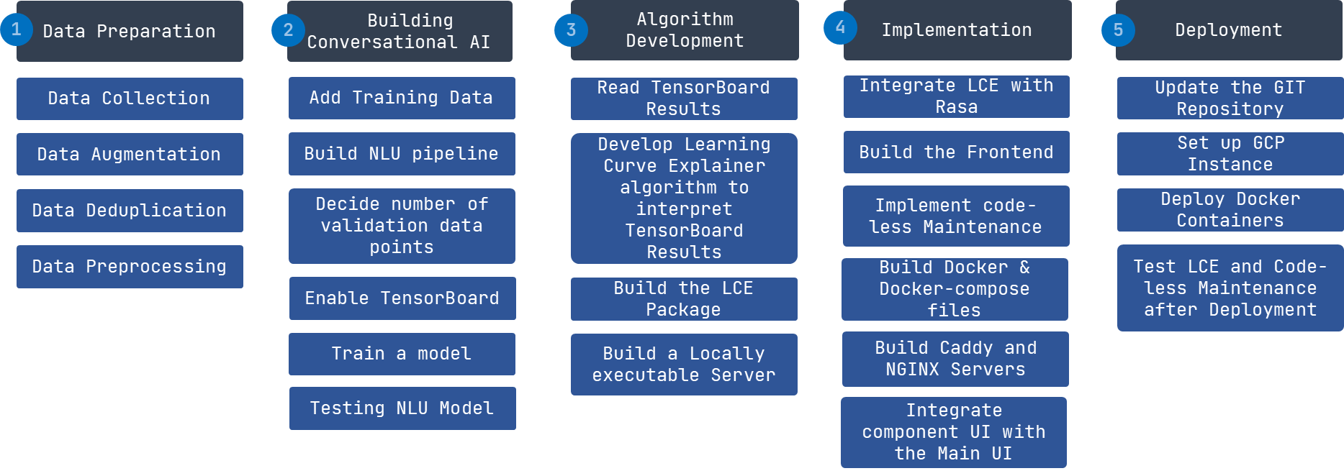

On-going

Pending

Completed